Women Safety App with SOS & Live Tracking
A Project Report Submitted in the partial fulfillment of the requirements for the award of the degree of

BACHELOR OF TECHNOLOGY
In

DEPARTMENT OF COMPUTER SCIENCE ENGINNERING
By

HAMSIKA PEDDINA 2520030586
THANISHKA MANNE 2520030583

Under the Esteemed Guidance

Dr D Ramya Krishna
Assistant Professor
Department of Computer Science and Engineering




K L (Deemed to be) University
DEPARTMENT OF COMPUTER SCIENCE ENGINEERING
&

DEPARTMENT OF COMPUTER SCIENCE AND INFORMATION TECHNOLOGY

Declaration

The Project Report entitled “Women Safety App with SOS & Live Tracking ” is a record of Bonafide work of HAMSIKA PEDDINA - 2520030586 , THANISHKA MANNE - 2520030583 submitted in partial fulfillment for the award of B. Tech in Computer Science and Engineering (or) Computer Science and Information Technology to the K L University. The results embodied in this report have not been copied from any other departments/University/Institute.

MANNE THANISHKA – 2520030583 HAMSIKA PEDDINA – 2520030586
K L (Deemed to be) University

DEPARTMENT OF COMPUTER SCIENCE ENGINEERING

&

DEPARTMENT OF COMPUTER SCIENCE AND INFORMATION TECHNOLOGY

CERTIFICATE

This is certify that the mini project based report entitled“Women Safety App with SOS & Live Tracking ” is a bonafide work done and submitted by HAMSIKA PEDDINA - 2520030586 , MANNE THANISHKA - 2520030583
in partial fulfillment of the requirements for the award of the degree of BACHELOR OF TECHNOLOGY in Department of Computer Science Engineering, K L (Deemed to be University), during the academic year 2026-2027.

Signature of the Guide

Signature of the Course Coordinator Signature of the HOD
ACKNOWLEDGEMENT
The success in this project would not have been possible but for the timely help and guidance rendered by many people. Our wish to express my sincere thanks to all those who has assisted us in one way or the other for the completion of my project.

Our greatest appreciation to my Course Coordinator Dr R Sateesh Kumar , and my guide
Dr D Ramya Krishna , Department of Computer Science which cannot be expressed in words for his/her tremendous support, encouragement and guidance for this project.

We express our gratitude to Dr. P Venkateshwara Rao (CSE) Head of the Department for Computer Science Engineering/ Department for Computer Science and Information Technology for providing us with adequate facilities, ways and means by which we are able to complete this project-based Lab.

We thank all the members of teaching and non-teaching staff members, and also who have assisted me directly or indirectly for successful completion of this project. Finally, I sincerely thank my parents, friends and classmates for their kind help and cooperation during my work.

MANNE THANISHKA – 2520030583 HAMSIKA PEDDINA – 2520030586

ABSTRACT
Women’s safety is an important concern that requires quick access to emergency assistance, reliable communication, and location-based safety support. To address these needs, the Women Safety Application is developed as a web-based safety platform that provides users with multiple tools for handling emergency and potentially unsafe situations.
The application provides features such as user authentication, emergency contact management, Normal SOS, Secret SOS, location tracking and sharing, safety timer, safety check-in, safe zones, and fake call functionality. These features are designed to provide users with different ways to respond to emergency situations depending on their circumstances. The system also integrates location-related services to support location awareness and emergency assistance.
The application follows a full-stack architecture consisting of a React and Vite-based frontend, Node.js and Express.js backend, and MySQL database. The frontend provides the user interface through which users can access and manage safety features, while the backend handles application logic, authentication, API communication, and interaction with the database. MySQL is used to store and manage application data such as user information and emergency-related records. The application is deployed using Railway, making the system accessible through a web browser.
The proposed system aims to provide a centralized and accessible platform for personal safety management. By combining emergency alert mechanisms, location-based functionality, safety monitoring tools, and emergency contact management within a single application, the system provides users with practical safety-support features that can be accessed when required. The project demonstrates the application of modern web technologies to develop a technology-assisted solution for women’s personal safety and emergency preparedness.

Index

S. No. | Chapters | Topics | Page.no
 |  | Acknowledgement | 4
 |  | Abstract | 5
1 | Introduction | 1.1 Background of the Project  1.2 Problem Statement  1.3 Scope of the Project  1.4 Objectives  1.5 Importance of the Application  1.6 Target Users / Audience  1.7 Summary | 8–14
2 | System Requirements | 2.1 Hardware Requirements  2.2 Software Requirements  2.3 Functional Requirements  2.4 Non-Functional Requirements  2.5 Development Environment  2.6 System Requirements Summary | 15–21
3 | Technology Stack | 3.1 Introduction  3.2 Front-End Technology  3.3 Back-End Technology  3.4 Database Technology  3.5 Authentication and Security  3.6 Location and Geolocation Services  3.7 API Communication  3.8 Development Environment  3.9 Version Control  3.10 Deployment Technology  3.11 Technology Integration  3.12 Advantages of the Selected Technology Stack  3.13 Summary | 22–33
4 | System Architecture | 4.1 High-Level Architecture Diagram  4.2 Description of Each Layer (Frontend, Backend, Database)  4.3 Deployment Architecture | 34–38
5 | Design | 5.1 Design Overview  5.2 ER Diagram / Database Schema | 39–40
6 | Implementation | 6.1 Module-Wise Implementation  6.2 Front-End Logic  6.3 API Integration  6.4 Authentication and Authorization | 41–45
7 | Features | 7.1 List of Main Features  7.2 How Each Feature Works | 46–50
8 | Testing | 8.1 Postman Testing (Frontend/Backend)  8.2 Integration Testing  8.3 Tools Used for Testing  8.4 Test Cases and Results | 51–53
9 | Deployment | 9.1 Steps to Deploy  9.2 Environment Configuration  9.3 Hosting of Frontend and Backend | 54–55
10 | Challenges & Limitations | 10.1 Issues Faced During Development  10.2 Solutions Applied  10.3 Current Limitations or Known Bugs | 56–59
11 | Future Enhancements | 11.1 Planned Features  11.2 Possible Integrations or Optimizations | 60–68
12 | Conclusion | 12.1 Summary of the Project  12.2 What Was Achieved  12.3 Skills Learned During Development | 69–79
13 | References | • Books, Tutorials, APIs, and Documentation Sites Used | 80–81
14 | Appendices | • Screenshots of the App  • Sample Code Snippets  • Installation / Setup Instructions  • User Manual / Guide  • Geo Tag Photos with Guide  • Review Forms with Guide Signatures | 82–92

CHAPTER 1 — INTRODUCTION

1.INTRODUCTION
Women’s safety is an important concern in everyday life, particularly when individuals travel alone, commute during late hours, or encounter unexpected situations. Technology can provide useful tools for improving personal safety by making emergency communication, location sharing, and safety monitoring more accessible.
The Women Safety Application is a web-based platform developed to provide multiple safety-oriented features through a single application. Instead of depending on one emergency mechanism, the system provides different tools such as Normal SOS, Secret SOS, emergency contact management, location-related functionality, safety timer, safety check-in, safe zones, and fake call.
The application is developed using a full-stack architecture. The frontend provides the user interface, the backend manages application logic and API communication, and the MySQL database stores and manages application data. The system is designed to provide users with an organized platform for managing personal safety and emergency-related activities.
The application is intended to support users during potentially unsafe situations by providing accessible safety mechanisms while also demonstrating the practical application of modern web development, database management, authentication, and API-based communication.

1.1 Background of the Project
Personal safety situations can occur unexpectedly during travelling, commuting, studying, working, or performing routine activities. In such situations, a person may need to quickly contact trusted individuals, communicate their location, or activate a safety mechanism.
Traditional emergency communication may require several manual actions. A user may need to find a contact, make a call, explain the situation, and separately communicate their location. This can become difficult when the user is under stress or has limited time to respond.
The Women Safety Application was developed to bring multiple safety-related functions into one platform. Users can configure emergency contacts in advance and access different safety features according to their circumstances. The system also provides location-related functionality and safety monitoring mechanisms such as timers and check-ins.
The project combines frontend development, backend services, database management, authentication, and location-based functionality to create a centralized safety-support application.

1.2 Problem Statement
In an emergency situation, users may not always have sufficient time or ability to manually communicate their situation to multiple people. Using separate applications for emergency communication, location sharing, and safety monitoring can also make the process more complicated.
The main problem addressed by this project is the need for a centralized and accessible application that provides multiple personal safety and emergency-support mechanisms in one system.
The application aims to simplify access to safety features by providing emergency contact management, SOS mechanisms, location-related functionality, safety monitoring tools, and additional safety features through a single web-based platform.

1.3 Scope of the Project
The scope of the project covers the design, development, database management, testing, and deployment of a web-based Women Safety Application.
The major areas covered by the system include:
- User registration and authentication
- User account management
- Emergency contact management
- Normal SOS
- Secret SOS
- Location-related safety functionality
- Safety timer
- Safety check-in
- Safe zones
- Fake call functionality
- Backend API services
- MySQL database management
- Frontend and backend integration
- Deployment of the application for online access
The project focuses on providing software-based tools that can assist users in managing personal safety and communicating emergency-related information.
The application is intended to act as a support system and does not replace emergency services, law enforcement, medical assistance, or other professional emergency-response organizations.

1.4 Objectives
The primary objective of the project is to develop a centralized web-based Women Safety Application that provides users with multiple safety and emergency-support features.
The specific objectives are:
- To develop an accessible and user-friendly Women Safety Application.
- To provide secure user authentication and account management.
- To allow users to manage trusted emergency contacts.
- To implement a Normal SOS mechanism for emergency situations.
- To implement a Secret SOS mechanism for situations requiring discreet interaction.
- To provide location-related functionality for safety and emergency purposes.
- To implement a safety timer for monitoring user-defined safety periods.
- To provide a safety check-in mechanism.
- To provide safe-zone functionality.
- To provide a fake call feature as an additional safety tool.
- To manage application data using a MySQL database.
- To establish communication between the frontend and backend through APIs.
- To integrate the different safety modules into a single application.
- To deploy the application so that it can be accessed online.
- To demonstrate the practical application of full-stack web development and database management concepts to a real-world problem.

1.5 Importance of the Application
The importance of the Women Safety Application comes from its ability to combine several safety-oriented functions within a single platform.

1.5.1 Emergency Communication
The application provides dedicated mechanisms for users to initiate emergency-related actions instead of requiring them to manually coordinate every step during a stressful situation.

1.5.2 SOS Functionality
SOS is one of the central components of the application. The system provides both Normal SOS and Secret SOS, allowing users to access different emergency mechanisms depending on their circumstances.

1.5.3 Emergency Contact Management
Users can maintain trusted emergency contacts within the application. This provides an organized way of managing the people who may need to be involved during an emergency.

1.5.4 Location-Based Safety
Location functionality adds important context to safety-related activities. Location information can help communicate where assistance may be required and can support other safety features of the application.

1.5.5 Safety Monitoring
Features such as the Safety Timer and Safety Check-in provide additional mechanisms for users to monitor their safety during activities such as travelling or commuting.

1.5.6 Safe Zone Support
The Safe Zone feature provides a way to incorporate predefined safety-related locations into the application and supports the broader goal of location-aware personal safety.

1.5.7 Fake Call Feature
The Fake Call feature provides an additional safety mechanism that can be used by a person who wants to create a reason to leave or disengage from an uncomfortable situation.

1.5.8 Centralized Safety Platform
Instead of requiring separate tools for different safety requirements, the application combines multiple functions within one platform. This provides a centralized interface through which users can access and manage safety features.

1.5.9 Database Management
The application also demonstrates the practical use of a relational database for managing application information. MySQL provides structured storage for the data required by the system and allows relationships between different categories of application information to be maintained.

1.5.10 Full-Stack Technology Integration
The project demonstrates the integration of a modern frontend, backend services, database management, authentication, APIs, and deployment within a single application. This makes the project relevant not only as a safety solution but also as a practical implementation of full-stack software development concepts.

1.6 Target Users / Audience
The primary target audience of the Women Safety Application is women who require convenient access to personal safety and emergency-support features.
The application can be relevant to the following users:

1.6.1 Women and Girls
Women and girls can use the application to access safety features such as SOS, emergency contacts, safety timers, check-ins, and other available safety mechanisms.

1.6.2 College and University Students
Students may use the application while travelling between home and educational institutions, attending events, commuting alone, or travelling during late hours.

1.6.3 Working Women
Working women who commute regularly or work during extended or irregular hours can use the application as an additional personal safety tool.

1.6.4 Women Travelling Alone
Users travelling alone may benefit from having emergency contacts and safety features readily available through a centralized application.

1.6.5 Daily Commuters
Users who regularly travel using public or private transportation can use the application's safety mechanisms during their journeys.

1.6.6 Hostel and PG Residents
Women living in hostels, paying-guest accommodations, or shared residences can use the application while travelling between their accommodation and other locations.

1.6.7 Trusted Contacts
Parents, guardians, family members, and trusted friends can act as emergency contacts associated with a user's account. Their role is to receive or respond to emergency-related information when applicable.

1.6.8 Academic and Technical Users
From an academic perspective, the project can also be useful for students studying web development, database management, software engineering, authentication, API development, and application deployment.

1.7 Summary
The Women Safety Application provides a centralized platform for personal safety and emergency preparedness. By combining Normal SOS, Secret SOS, emergency contacts, location functionality, safety timers, safety check-ins, safe zones, and fake calls, the application provides users with multiple safety-oriented tools within a single system.
The project also demonstrates the practical integration of frontend development, backend services, database management, authentication, APIs, and deployment. Through this combination of safety functionality and full-stack technology, the project addresses a practical real-world requirement while demonstrating important software development and database concepts.

CHAPTER 2 — SYSTEM REQUIREMENTS

2.1 Hardware Requirements
Requirement | Specification
Processor | Intel Core i3 or above
RAM | Minimum 4 GB, 8 GB recommended
Storage | Minimum 10 GB free space
Display | 1366 × 768 resolution or higher
Internet | Stable internet connection
Mobile Device | Smartphone with a modern web browser for testing
GPS/Location | Location-enabled device for location-based safety features

2.2 Software Requirements
The Women Safety Application uses a full-stack web architecture consisting of a frontend, backend, relational database, and deployment environment.
The major software requirements are described below.

Software | Requirement
Operating System | Windows 10/11, Linux, or macOS
Frontend | React with Vite
Programming Language | JavaScript
Backend | Node.js
Server Framework | Express.js
Database | MySQL
Database Management | MySQL Workbench
Web Browser | Google Chrome, Microsoft Edge, or Mozilla Firefox
Version Control | Git
Repository | GitHub
Deployment Platform | Railway

2.3 Functional Requirements
Functional requirements describe the operations that the Women Safety Application is expected to provide to its users. The major functional requirements of the system are:
- User Registration and Login
The system shall allow users to create an account and securely log in to access the application.
- User Profile Management
The system shall allow users to view and update their personal profile information.
- Emergency Contact Management
The system shall allow users to add, edit, and manage emergency contacts who can be contacted during an emergency.
- Normal SOS
The system shall provide an SOS feature that allows the user to trigger an emergency alert when immediate assistance is required.
- Secret SOS
The system shall provide a discreet SOS mechanism that allows the user to trigger an emergency alert without attracting attention.
- Location and Live Tracking
The system shall allow the user to access their current location and provide live location tracking functionality for emergency situations.
- Safety Timer
The system shall allow users to start a safety timer and provide an alert when the configured time expires without the user completing the required action.
- Safety Check-in
The system shall allow users to perform safety check-ins to indicate that they are safe.
- Safe Zones
The system shall allow users to manage designated safe locations and use them as part of the application's safety features.
- Fake Call
The system shall provide a fake-call feature that simulates an incoming call to help the user exit an uncomfortable or potentially unsafe situation.
- Backend API Integration
The system shall communicate with the backend through APIs for authentication, user data, emergency contacts, and safety-related operations.
- Database Management
The system shall store and retrieve required user and application data using the MySQL database.
- Authentication and Authorization
The system shall authenticate users and restrict access to protected application resources based on their authenticated session.

2.4 Non-Functional Requirements
Non-functional requirements describe the quality characteristics expected from the application.

2.4.1 Usability
The application should provide a clear and understandable interface so that users can access important safety features without unnecessary complexity.

2.4.2 Performance
The application should respond to user actions and API requests within a reasonable amount of time under normal operating conditions.

2.4.3 Reliability
The system should perform its implemented functions consistently and handle application operations without unnecessary failures.

2.4.4 Security
User accounts and application data should be protected through appropriate authentication and backend security mechanisms.
Sensitive configuration values such as database credentials, API keys, and authentication secrets should not be exposed in the application's source code or public repository.

2.4.5 Maintainability
The application should have a structured frontend and backend architecture so that individual modules can be maintained and improved without unnecessarily affecting unrelated parts of the system.

2.4.6 Scalability
The application architecture should allow additional safety features and improvements to be added in future versions.

2.4.7 Accessibility
The application should be accessible through commonly used modern web browsers and should provide an interface that is understandable to its intended users.

2.4.8 Availability
Since the application is deployed online, users should be able to access the application whenever the deployed services are available and the user has the required internet connectivity.

2.5 Development Environment
The development environment consists of the tools and technologies required to build, test, and deploy the application.
The major development components are:

Component | Technology
Frontend | React
Frontend Build Tool | Vite
Backend Runtime | Node.js
Backend Framework | Express.js
Database | MySQL
Code Editor | Visual Studio Code
Version Control | Git
Repository | GitHub
Deployment Platform | Railway
Browser | Google Chrome / Microsoft Edge / Mozilla Firefox
Location Services | Browser/device location services and applicable Google location services
These technologies work together to form the complete development and deployment environment of the Women Safety Application.

2.6 System Requirements Summary
The Women Safety Application requires a standard development computer, a modern web browser, internet connectivity, and access to location services for applicable features.
The software environment consists primarily of React, Vite, Node.js, Express.js, and MySQL, supported by development and deployment tools such as Visual Studio Code, Git, GitHub, and Railway.
The combination of these technologies provides the required environment for developing the frontend, implementing backend services, managing application data, integrating safety-related functionality, and deploying the application for online access.

CHAPTER 3 — TECHNOLOGY STACK

3.1 Introduction
The Women Safety Application is developed using a full-stack web architecture that combines a modern frontend, backend services, relational database, development tools, version control, and cloud deployment.
The major technologies used in the project are React, Vite, JavaScript, Node.js, Express.js, MySQL, Git, GitHub, and Railway. Location-related functionality is supported through browser/device location capabilities and the location services implemented in the application.
Each technology is responsible for a specific layer of the system. React and Vite are used for the frontend, Node.js and Express.js provide the backend services, MySQL manages persistent application data, Git and GitHub support version control, and Railway is used for deployment.

3.2 Front-End Technology

3.2.1 React
React is the primary frontend library used to develop the user interface of the Women Safety Application.
React allows the application to be divided into reusable components and provides an efficient way to build interactive user interfaces. The different sections of the application can be organized into components based on their functionality.
The frontend can provide interfaces for:
- User authentication
- Dashboard
- Emergency contacts
- Normal SOS
- Secret SOS
- Safety timer
- Safety check-in
- Safe zones
- Fake call
- Location-related functionality
- User account management
React helps maintain a structured and component-based frontend architecture.

3.2.2 Vite
Vite is used as the frontend development and build tool for the React application.
It provides a fast development environment and supports the process of developing and building the frontend application.
Vite is responsible for supporting the frontend development workflow and generating the production-ready frontend build.

3.2.3 JavaScript
JavaScript is the programming language used throughout the application.
It is used to implement application logic, user interactions, frontend functionality, API communication, and other dynamic operations.
JavaScript enables the frontend to communicate with the backend and respond to user actions.

3.3 Back-End Technology

3.3.1 Node.js
Node.js is used as the runtime environment for the backend of the application.
It allows JavaScript code to execute on the server side and provides the environment required for running the backend services.
Node.js is responsible for supporting operations such as:
- Running the backend server
- Processing requests
- Managing dependencies
- Executing server-side JavaScript
- Supporting API operations
- Communicating with the database

3.3.2 Express.js
Express.js is the backend web framework used with Node.js.
It provides the structure required to create and manage the application's backend API.
Express.js handles operations such as:
- API routing
- HTTP requests and responses
- Backend application logic
- Authentication-related operations
- Database communication
- Error handling
- Communication between frontend and backend
The Express.js backend acts as an intermediate layer between the React frontend and MySQL database.

3.4 Database Technology

3.4.1 MySQL
MySQL is used as the relational database management system for the Women Safety Application.
The database provides persistent storage for information required by the application's different modules.
Depending on the implemented functionality, the database manages information associated with areas such as:
- User accounts
- Authentication
- Emergency contacts
- SOS-related information
- Safety-related records
- Location-related information
- Other application data
MySQL supports important relational database concepts including:
- Tables
- Primary keys
- Foreign keys
- Relationships
- SQL queries
- Data retrieval
- Data modification
The database provides the persistent data layer of the application.

3.5 Authentication and Security
Authentication is an important part of the Women Safety Application because user-specific safety information should only be accessible to the appropriate authenticated user.
The application uses an authentication mechanism between the frontend and backend to control access to protected functionality.
The authentication system is responsible for operations such as:
- User registration
- User login
- Authentication verification
- Protected application access
- Maintaining authenticated user sessions
- Restricting unauthorized access
Security-sensitive configuration values such as authentication secrets, database credentials, and API keys should be stored through environment configuration rather than exposed directly in the source code.

3.6 Location and Geolocation Services
Location functionality is an important component of the Women Safety Application.
The application can use the location capabilities available through the user's device and browser to obtain geographical information where required by its safety features.
Location-related functionality can support features such as:
- Emergency location information
- Location sharing
- Safe zones
- Location-aware safety operations
The availability and accuracy of location information depend on factors such as device capabilities, browser permissions, location settings, and internet connectivity.

3.7 API Communication
The frontend and backend communicate through APIs.
The general communication process can be represented as:
User
↓
React Frontend
↓
HTTP/API Request
↓
Express.js Backend
↓
Application Logic
↓
MySQL Database
↓
Backend Response
↓
React Frontend
This architecture separates the user interface from the server-side processing and database layer.
API-based communication allows the frontend to request data and perform operations without directly accessing the database.

3.8 Development Environment

3.8.1 Visual Studio Code
Visual Studio Code (VS Code) is used as the primary code editor and development environment.
It is used for:
- Writing source code
- Managing project files
- Developing frontend components
- Developing backend services
- Editing configuration files
- Debugging the application
- Running development commands

3.8.2 Node Package Manager
The Node.js development environment uses a package management system to install and maintain the libraries and dependencies required by the application.
Project dependencies are maintained through the project's package configuration and installed during development and deployment.

3.8.3 Web Browser
A modern web browser is required to run and test the frontend application.
Browsers such as Google Chrome, Microsoft Edge, and Mozilla Firefox can be used to access the application.
The browser provides the environment in which the React application is executed and also provides access to browser-supported functionality such as location permissions.

3.9 Version Control

3.9.1 Git
Git is used as the version control system for the project.
It allows developers to maintain the history of source-code changes and manage different versions of the application.
Git provides capabilities such as:
- Tracking code changes
- Creating commits
- Maintaining project history
- Reverting changes when required
- Managing development branches
- Supporting collaborative development

3.9.2 GitHub
GitHub is used as the remote repository platform for the project.
The project source code can be maintained in a GitHub repository, allowing the development team to manage and share the project code.
GitHub also supports the deployment workflow by providing a source repository that can be connected to deployment services.

3.10 Deployment Technology

3.10.1 Railway
Railway is used as the deployment platform for the application.
The application is deployed online so that users can access it through a web browser without running the development environment locally.
The production application is available at:
https://dbse-and-dbd-project-production.up.railway.app/
The deployment environment provides the infrastructure required to run the application's production services.

3.10.2 Production Environment
The production environment consists of the deployed application and its required backend and database services.
The general deployment architecture can be represented as:
User Browser
↓
Deployed Frontend
↓
Backend API
↓
MySQL Database
The production environment allows the different components of the application to communicate with each other over the network.

3.11 Technology Integration
The different technologies used in the project work together to form a complete application.
The overall technology flow is:
React + Vite
↓
Node.js + Express.js
↓
MySQL
The supporting development and deployment tools are:
Visual Studio Code → Git → GitHub → Railway
Each layer has a specific responsibility:

Layer | Technology | Purpose
Frontend | React | User interface
Build Tool | Vite | Frontend development and build
Programming Language | JavaScript | Application logic
Backend Runtime | Node.js | Server-side execution
Backend Framework | Express.js | API and server management
Database | MySQL | Persistent data storage
Version Control | Git | Source-code management
Repository | GitHub | Remote source-code management
Development Tool | Visual Studio Code | Code development
Deployment | Railway | Online application hosting
Location | Browser/Device Location Services | Location-related functionality

3.12 Advantages of the Selected Technology Stack
The selected technology stack provides several advantages for the Women Safety Application.

3.12.1 Component-Based Frontend
React allows the interface to be divided into reusable components, making the frontend easier to organize and maintain.

3.12.2 Efficient Development
Vite provides a fast development and build environment for the React application.

3.12.3 JavaScript-Based Full Stack
Using JavaScript across the frontend and backend simplifies development by allowing the same primary programming language to be used throughout the application.

3.12.4 Structured Backend
Node.js and Express.js provide a structured environment for implementing APIs and backend application logic.

3.12.5 Relational Data Management
MySQL provides structured and persistent storage for application information and supports relationships between related data.

3.12.6 Version Control
Git and GitHub provide a reliable method for managing source-code changes and maintaining project history.

3.12.7 Online Accessibility
Railway allows the completed application to be deployed online and accessed through a web browser.

3.12.8 Expandability
The selected architecture provides a foundation on which additional safety features and improvements can be developed in future versions.

3.13 Summary
The Women Safety Application uses a modern full-stack technology stack consisting of React, Vite, JavaScript, Node.js, Express.js, and MySQL.
React and Vite provide the frontend environment, while Node.js and Express.js provide the backend API layer. MySQL provides persistent relational data storage. Git and GitHub support version control and project management, while Railway provides the deployment environment.
The integration of these technologies creates a structured architecture in which the frontend, backend, database, and deployment layers work together to provide the application's safety-related functionality.

CHAPTER 4 – SYSTEM ARCHITECTURE

High-level architecture diagram

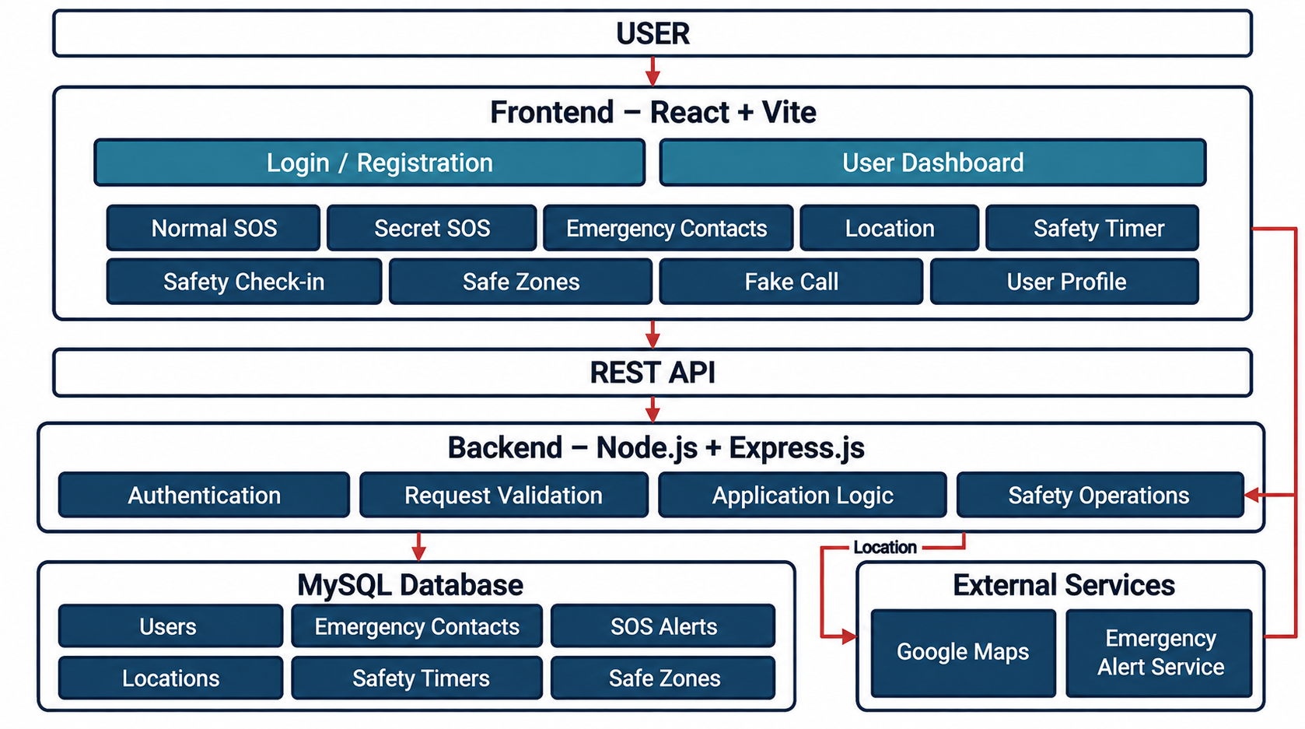

Description of Each Layer (Frontend, Backend, Database)

The system architecture of the Women Safety Application is divided into three main layers: Frontend, Backend, and Database, with external services integrated where required. Each layer has a specific responsibility and works together to provide the safety features of the application.

1. Frontend Layer
The Frontend Layer is the user-facing part of the Women Safety Application, developed using React and Vite. It provides the interface through which users can log in, access the dashboard, and use different safety features.
Main components:
- Login / Registration: Allows users to create an account and securely log in.
- User Dashboard: Provides access to the main safety features.
- Normal SOS: Allows the user to trigger an emergency alert.
- Secret SOS: Provides a discreet way to request emergency assistance.
- Emergency Contacts: Allows users to manage their emergency contacts.
- Location: Provides access to the user's location.
- Safety Timer: Helps users monitor a predefined safety period.
- Safety Check-in: Allows users to confirm that they are safe.
- Safe Zones: Allows users to manage designated safe areas.
- Fake Call: Provides a simulated incoming call for safety situations.
- User Profile: Allows users to manage their profile information.
Functions:
- Provides an easy-to-use graphical interface.
- Accepts user input and safety-related actions.
- Sends requests to the backend through the REST API.
- Displays responses and information received from the backend.
- Provides access to all major safety features.

2. Backend Layer
The Backend Layer is developed using Node.js and Express.js. It handles API requests from the frontend, performs validation and application processing, manages safety operations, and communicates with the database and external services.
Main components:
- Authentication: Handles user authentication and access to authorized features.
- Request Validation: Validates data received from the frontend before processing.
- Application Logic: Handles the main application operations and business rules.
- Safety Operations: Processes safety-related actions such as SOS alerts, timers, check-ins, and other emergency functions.
Functions:
- Receives requests from the frontend through the REST API.
- Validates incoming requests and user data.
- Processes application and safety operations.
- Stores and retrieves required information from the MySQL database.
- Communicates with external services when required.
- Sends the processed response back to the frontend.

3. Database Layer
The Database Layer uses MySQL to store and manage the application's persistent data. The backend communicates with the database whenever information needs to be stored, retrieved, or updated.
Main data components:
- Users: Stores user account and profile information.
- Emergency Contacts: Stores the emergency contacts associated with users.
- SOS Alerts: Stores information related to triggered SOS alerts.
- Locations: Stores location-related information.
- Safety Timers: Stores safety timer information.
- Safe Zones: Stores user-defined safe zone information.
Functions:
- Stores application and user data.
- Retrieves data requested by the backend.
- Updates stored information when required.
- Maintains persistent records for safety-related operations.
- Provides structured data storage for the application.

4. External Services
The application also communicates with external services to provide additional safety functionality.
Main services:
- Google Maps: Supports location-related functionality and map-based services.
- Emergency Alert Service: Supports the delivery or processing of emergency alerts generated through safety features.

Overall Flow
User → Frontend → REST API → Backend → MySQL Database / External Services
The user interacts with the React + Vite Frontend to access the application's safety features. The frontend sends requests through the REST API to the Node.js + Express.js Backend. The backend validates and processes these requests, communicates with the MySQL Database when data is required, and interacts with external services such as Google Maps and the Emergency Alert Service when necessary. The processed results are then returned to the frontend and displayed to the user.

4.3 Deployment Architecture

- Deployment Architecture describes how the Women Safety Application is deployed and made available to users. The application source code is maintained in GitHub and connected to Railway for deployment. Railway provides the environment required to run the application and make it accessible through a public web URL.

- The deployed system consists of the React and Vite frontend, Node.js and Express.js backend, and MySQL database. The frontend communicates with the backend through REST APIs, while the backend handles application logic, authentication, safety-related operations, and database communication.

- The deployment workflow can be represented as:
Developer → GitHub → Railway → Deployed Women Safety Application

- This deployment approach allows changes pushed to the GitHub repository to be deployed to the Railway environment and accessed through the application's public URL.

Overall Deployment Flow
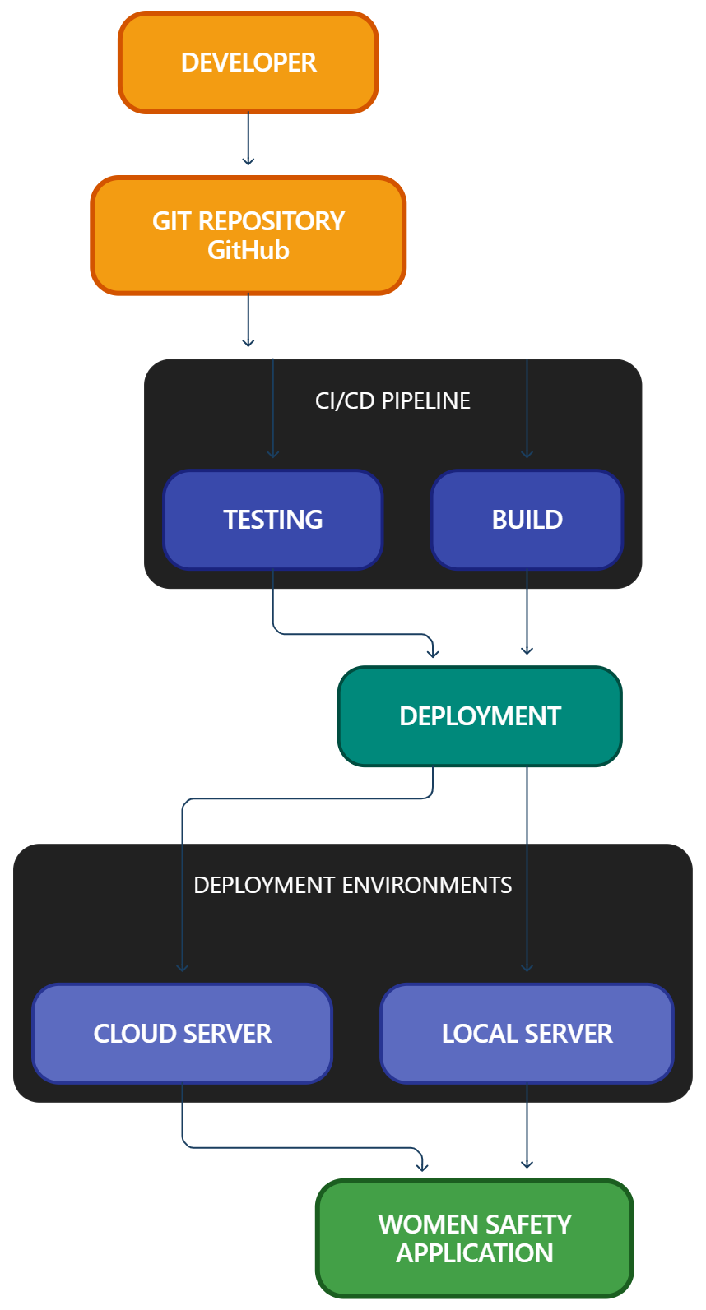

CHAPTER -5 DESIGN

5.1 Design Overview
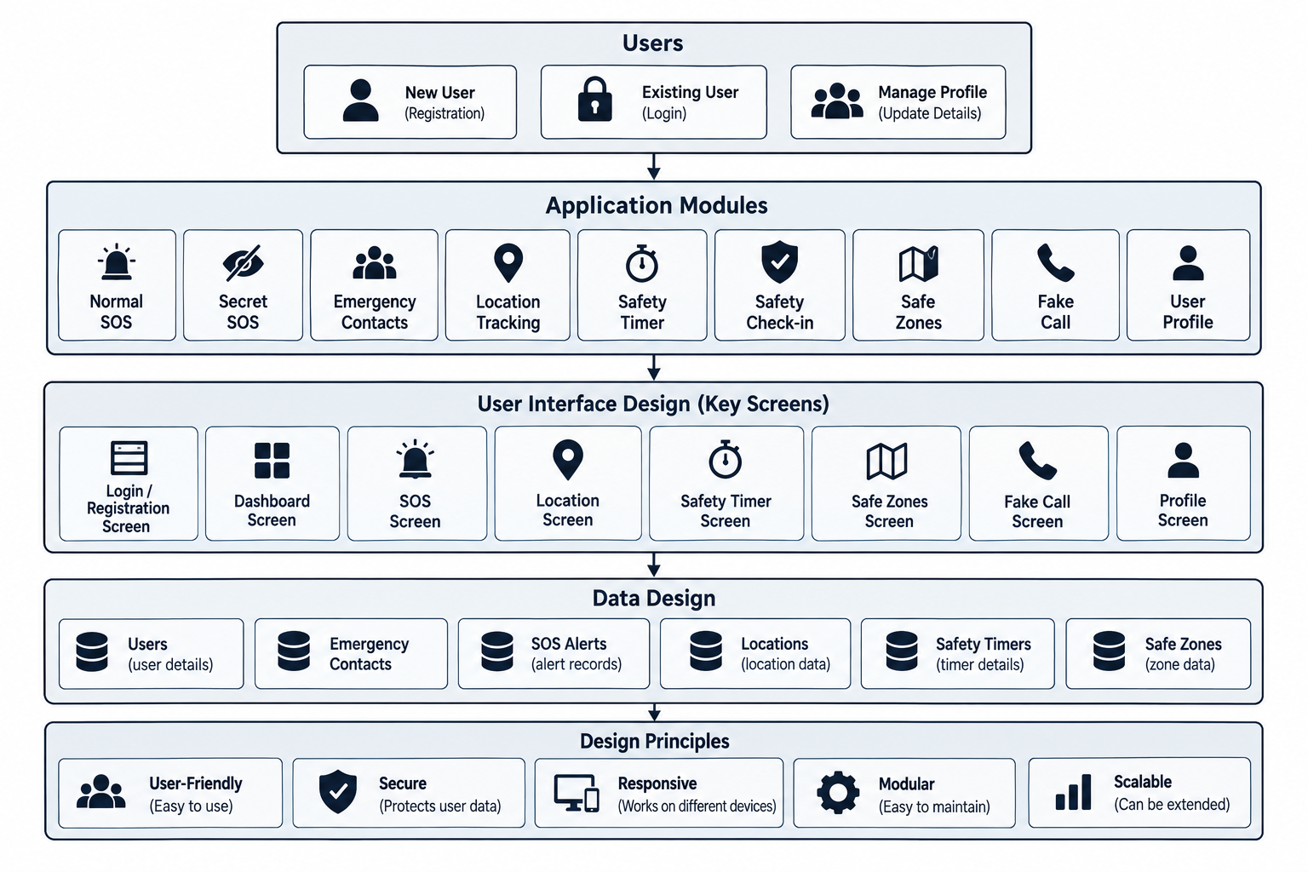

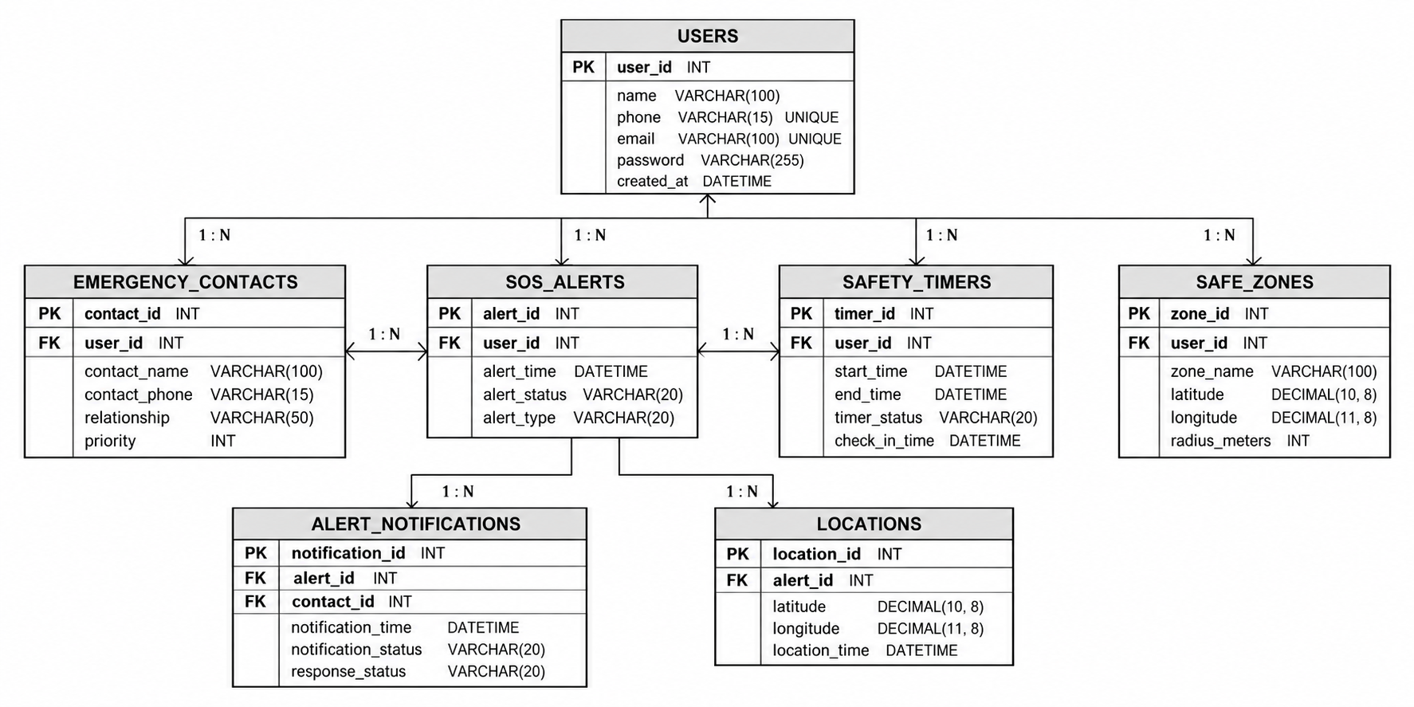

5.2 ER Diagram / Database Schema
The Entity Relationship (ER) Diagram represents the database structure of the Women Safety Application and shows how the major entities are related to each other. The database is designed using MySQL, with the Users entity acting as the central entity for user-specific safety information.
The Users table stores the basic information of registered users and uses user_id as its primary key. A user can have multiple emergency contacts, SOS alerts, safety timers, safe zones, locations, and related alert notifications.
The Emergency Contacts table stores the trusted contacts associated with a user. It uses contact_id as its primary key and user_id as a foreign key referring to the Users table. This relationship allows each user to maintain multiple emergency contacts.
The SOS Alerts table stores information about SOS events generated by users. It contains details such as the alert time, alert status, and alert type. The user_id foreign key connects each SOS alert with the corresponding user.
The Safety Timers table stores safety timer information associated with users. It contains details such as the start time, end time, timer status, and check-in time. The user_id foreign key establishes the relationship between users and their safety timers.
The Safe Zones table stores locations defined by users as safe areas. It contains information such as the zone name, latitude, longitude, and radius. The user_id foreign key connects each safe zone with its respective user.
The Locations table stores location information associated with SOS alerts. It contains latitude, longitude, and location time details. The alert_id foreign key connects location records with the corresponding SOS alert.
The Alert Notifications table stores notification information related to SOS alerts. It contains notification time, notification status, and response status. The alert_id foreign key connects notifications with the relevant SOS alert.
Overall, the ER diagram represents the relationships between users and the major safety-related data maintained by the application. The use of primary keys and foreign keys helps maintain relationships between tables and supports structured storage and retrieval of application data.

CHAPTER -6 IMPLEMENTATION

6.1 Module-Wise Implementation
The Women Safety application was implemented as a full-stack web application consisting of a React-based frontend, a Node.js and Express.js backend, and a MySQL database. The implementation was divided into different functional modules so that each part of the system could be developed, tested, and integrated systematically. This modular approach also made it easier to identify errors and maintain the application during development.

6.1.1 User Registration Module
The registration module allows a new user to create an account in the Women Safety application. The user provides the required registration information through the frontend form. The entered information is sent to the backend through an API request, where it is validated and processed before being stored in the MySQL database.
The module is connected to the authentication system so that successfully registered users can later log in to the application. Input validation is performed to ensure that the required information is provided correctly. This module forms the initial entry point for users who are accessing the system for the first time.

6.1.2 Login and Authentication Module
The login module allows registered users to access their accounts. The user enters the required login credentials through the frontend, and the information is sent to the Express.js backend for verification. The backend checks the provided credentials against the stored user information.
After successful authentication, a JWT-based authentication mechanism is used to maintain the user's authenticated session. Protected application functionality can then be accessed by the authenticated user. Invalid login information is rejected and an appropriate response is provided to the frontend.

6.1.3 User Profile Module
The User Profile module provides functionality for managing user-related information. After logging in, users can access their profile information through the application dashboard. Profile data is retrieved through the backend and displayed through the React interface.
When the user modifies profile information, the updated data is sent to the backend and stored in the database. This ensures that the user's information remains available across different sessions.

6.1.4 Emergency Contacts Module
The Emergency Contacts module allows users to maintain important contact information within the application. Users can add emergency contacts through the frontend interface and store the information in the MySQL database.
The module also supports managing previously stored contacts. Backend APIs are used to perform the required database operations, while the frontend displays the current contact information to the user.

6.1.5 Normal SOS Module
The Normal SOS module provides a direct method for activating an emergency-related safety action. The user can access the SOS function from the application interface and activate it when required.
The frontend handles the user's interaction and communicates with the backend when server-side processing is required. The implementation connects the SOS functionality with the application's safety workflow and related information.

6.1.6 Secret SOS Module
The Secret SOS module provides an alternative method of activating a safety-related function. It is designed for situations where the user may prefer a less obvious interaction instead of using a conventional visible SOS action.
The frontend provides the required interaction mechanism, while the application logic processes the action according to the implemented safety workflow.

6.1.7 Location Module
The Location and Live Tracking module uses the browser Geolocation API to obtain the user's current location. During an active tracking session, the application continuously monitors the user's position and updates the location displayed on the application map. The module also handles location permissions and cases where location information is unavailable.

6.1.8 Safety Timer Module
The Safety Timer module allows the user to configure and start a safety timer. The frontend provides the timer controls and displays the current timer status to the user.
The module uses application logic to manage the selected duration and timer state. It is designed to provide a proactive safety mechanism through which the user can establish a specific period for checking their safety.

6.1.9 Safety Check-in Module
The Safety Check-in module allows users to confirm their safety status. The user interacts with the check-in interface, and the application processes the action according to the implemented workflow.
The feature is intended to provide a proactive mechanism through which users can indicate that they are safe after a particular activity or period.

6.1.10 Safe Zones Module
The Safe Zones module provides functionality for managing locations that the user considers safe. The user can configure relevant safe locations through the application interface.
The module uses location-related information and application logic to manage the configured safe-zone data. The availability of location functionality depends on browser permissions and device capabilities.

6.1.11 Fake Call Module
The Fake Call module provides a simulated call interface that can be activated by the user. The feature is designed as a safety-support mechanism that can provide the user with an opportunity to leave an uncomfortable situation.
The frontend controls the simulated call interface and manages the interaction with the user. The feature operates within the application and does not represent an actual emergency call.

6.2 Front-End Logic
The frontend of the Women Safety application was developed using React, Vite, and JavaScript. React is responsible for rendering the user interface and managing the different application views and interactive components. The frontend is structured so that users can move between authentication, dashboard, profile, emergency contacts, and safety-related functionality.

UI Rendering
React is used to render application components based on the current application state. Forms, buttons, dashboards, cards, dialogs, alerts, and safety controls are displayed according to the user's interaction with the application.
The interface is designed to provide clear access to important safety functions. User actions such as submitting a form, adding an emergency contact, starting a timer, or activating a safety feature trigger the corresponding frontend logic.

State Management
State management is an important part of the frontend implementation. The application needs to maintain information such as authentication status, user information, form values, emergency contacts, timer status, location information, and feature-specific states.
React state mechanisms are used to update the interface whenever relevant information changes. For example, when a user adds an emergency contact, the interface can update to display the latest contact information. Similarly, when a timer is started, the displayed timer state changes according to the current status.

Form Handling
Forms are used throughout the application for registration, login, profile management, emergency contacts, and other user interactions. The frontend collects the required information, performs basic validation, and sends valid data to the backend through API requests.
Error messages and application responses are displayed through the interface so that users can understand whether an operation was successful or whether additional action is required.

Responsive Interface
The frontend is designed to provide an interface that can be accessed through modern web browsers on different screen sizes. The layout and controls are organized to make the application's major functionality accessible from the dashboard and related sections.

6.3 API Integration
The frontend and backend communicate through APIs implemented using Node.js and Express.js. API integration provides the communication layer between the React interface and the server-side application logic.
When a user performs an operation that requires backend processing, the frontend creates an HTTP request containing the required information. The Express.js backend receives the request, validates the information, performs the required operation, and returns a response.
For database-related operations, the backend communicates with the MySQL database. Information submitted through the frontend can therefore follow the complete flow:
User → React Frontend → Express.js API → MySQL Database → Express.js API → React Frontend → User
API integration is used for operations such as authentication, profile management, emergency contacts, and other application functionality that requires backend processing.
Postman was used during development to test backend API operations independently from the frontend. This helped verify request handling, responses, authentication, and database-related operations.

6.4 Authentication and Authorization
Authentication is implemented to ensure that users can securely access their accounts and user-specific functionality. The process begins when a user registers an account through the frontend. The registration information is sent to the backend, validated, and stored in the MySQL database.
During login, the user provides the required credentials. The backend verifies the credentials and, when authentication is successful, generates an authentication token using the JWT mechanism. The authenticated session allows the user to access protected application functionality.
Authorization is used to control access to user-specific resources. Requests to protected backend operations are checked for valid authentication information before the requested operation is performed. This helps prevent unauthorized access to information belonging to another user.
Authentication was tested using both valid and invalid credentials. Protected operations were also tested to ensure that unauthenticated requests were not processed as normal authenticated requests.

45CHAPTER 7- FEATURES

7.1 List of Main Features

The main features implemented in the Women Safety application are:

User Registration

User Login and Authentication

User Profile Management

Dashboard

Emergency Contacts

Normal SOS

Secret SOS

Location

Safety Timer

Safety Check-in

Safe Zones

Fake Call

Database Storage

Backend API Integration

Production Deployment

7.2 How Each Feature Works

7.2.1 User Registration

User Perspective:
A new user can create an account by opening the registration section and entering the required information. After submitting the registration form, the application processes the information and creates the user's account. Once registration is completed successfully, the user can use the login functionality to access the application.

Technical Description:
The React frontend collects the registration information and sends it to the Express.js backend through an API request. The backend validates the received information and performs the required database operation. The user information is stored in MySQL so that it can be retrieved during future login operations.

7.2.2 User Login and Authentication

User Perspective:
A registered user can enter their login credentials to access the application. After successful authentication, the user is taken to the application dashboard where the available safety features can be accessed.

Technical Description:
The frontend sends the login credentials to the backend. The Express.js server verifies the information against the stored user data. After successful verification, JWT-based authentication is used to establish the authenticated session. Protected requests can then include the required authentication information.

7.2.3 User Profile

User Perspective:
Users can access their profile section to view and manage their personal information. The profile provides a centralized location for user-related information associated with the account.

Technical Description:
The frontend requests the user's profile information from the backend. The Express.js server retrieves the relevant record from MySQL and returns it to the React application. When profile information is updated, the modified data is sent back to the backend and stored in the database.

7.2.4 Dashboard

User Perspective:
After logging in, users can access the main dashboard. The dashboard provides access to the application's major safety features and user-management functions.

Technical Description:
The dashboard is implemented using React components. The interface displays feature controls according to the user's authentication state and application data. User interactions with dashboard controls initiate the corresponding frontend functions and API requests.

7.2.5 Emergency Contacts

User Perspective:
Users can add and manage people who they want to identify as emergency contacts. The user can enter the required contact information and save it through the application.

Technical Description:
The contact information is collected through a React form and submitted to the Express.js backend. The backend processes the request and stores the information in MySQL. Existing contact information can also be retrieved and displayed through the frontend.

7.2.6 Normal SOS

User Perspective:
The Normal SOS feature provides the user with a direct and visible method of activating a safety-related action. The user can access the SOS control from the application and activate it when required.

Technical Description:
The React frontend handles the SOS interaction and triggers the implemented safety workflow. Where backend processing is required, the frontend communicates with the Express.js API. The backend processes the request according to the application's implementation.

7.2.7 Secret SOS

User Perspective:
Secret SOS provides an alternative method for activating a safety function. It is intended for situations where the user may prefer not to use a conventional visible SOS action.

Technical Description:
The frontend contains the required interaction logic for the Secret SOS feature. When the user performs the defined action, the application processes it through the implemented safety logic and performs the corresponding operation.

7.2.8 Location

User Perspective:
The Location feature allows the user to access location-related functionality. When location access is required, the browser asks the user for permission. After permission is granted, the application can use the available location information.

Technical Description:
The frontend interacts with the browser's location capabilities. The application handles the returned location information according to the implemented functionality. If permission is denied or location information cannot be obtained, the application handles the corresponding condition.

7.2.9 Safety Timer

User Perspective:
The user can configure and start a safety timer for a selected period. The timer provides a way for the user to establish a safety-related time period and monitor its progress.

Technical Description:
The timer is managed through frontend application state and timer logic. React updates the interface as the timer progresses and maintains the current timer status. The feature can interact with other safety functionality according to the implemented application workflow.

7.2.10 Safety Check-in

User Perspective:
The Safety Check-in feature allows users to confirm that they are safe. The user can access the check-in control and submit their current safety status.

Technical Description:
The frontend captures the user's check-in action and processes it through the application's logic. Where persistent storage or backend processing is required, the corresponding API request is sent to the Express.js backend and processed using the application's database services.

7.2.11 Safe Zones

User Perspective:
Users can create and manage locations that they consider safe. These locations can be maintained through the Safe Zones section of the application.

Technical Description:
Safe-zone information is managed through the frontend and, where applicable, stored through backend and database operations. Location-related information is handled according to the permissions and capabilities available through the user's browser and device.

7.2.12 Fake Call

User Perspective:
The Fake Call feature provides a simulated incoming-call interface. The user can activate the feature when they need a simple safety-support mechanism in an uncomfortable situation.

Technical Description:
The feature is implemented through frontend logic that displays and controls the simulated call interface. The application manages the required visual and interaction states without representing an actual telephone or emergency call.

7.2.13 Database Storage

User Perspective:
Users interact with the application normally without needing to directly access the database. Information entered through forms and application features can be stored and retrieved when required.

Technical Description:
MySQL is used as the relational database. The Express.js backend acts as the intermediary between the React frontend and MySQL. Database operations are performed by the backend, while the frontend receives the required results through API responses.

7.2.14 Backend API Integration

User Perspective:
The user experiences the application as a single system, even though different operations are performed by the backend. Actions such as login, managing contacts, and updating information are processed through the application's API layer.

Technical Description:
Express.js provides the backend API layer. The API receives requests from the React frontend, validates and processes the requests, communicates with MySQL when required, and returns appropriate responses. Postman was used to test these APIs independently.

7.2.15 Deployment

User Perspective:
Users can access the completed Women Safety application through a web browser without setting up the development environment on their own computer.

Technical Description:
The application was deployed using Railway. The project source code was maintained on GitHub, and the deployment environment was configured with the required environment variables and application settings. The production application is accessible through the deployed Railway URL.

CHAPTER -8 TESTING

8.1 Postman Testing (Frontend/Backend)
Postman was used to test the backend APIs of the Women Safety application. The API requests were tested to verify communication between the frontend and backend and to ensure that the backend processes requests and returns the expected responses.
The following operations were tested:
- User registration and login
- Authentication and authorization
- User profile operations
- Emergency contact operations
- SOS-related requests
- Safety-related operations
- Location-related requests
- Database-related API operations
The API responses, status codes, request data, and response data were checked during testing. Successful responses confirmed that the backend services were communicating correctly with the application.

8.2 Integration Testing
Integration testing was performed to verify the interaction between the major components of the application.
The following integrations were tested:
- React frontend with Express.js backend
- Express.js backend with MySQL database
- User authentication with database records
- Emergency contacts with backend and database
- SOS and safety features with backend services
- Location-related functionality with the application
- Deployed frontend and backend communication
The testing confirmed that the major components work together as an integrated system and that data is transferred correctly between the frontend, backend, and database.

8.3 Tools Used for Testing
Testing Tool | Purpose
Postman | Testing backend APIs and HTTP requests
Web Browser | Testing the frontend user interface and functionality
MySQL Workbench | Verifying database records and SQL operations
Visual Studio Code | Debugging and testing application code
Git/GitHub | Managing and testing different code versions
Railway | Testing the deployed production application

8.4 Test Cases and Results
Test Case | Test Description | Expected Result | Result
TC01 | User Registration | User account should be created successfully | Pass
TC02 | User Login | Valid user should be authenticated successfully | Pass
TC03 | Invalid Login | Invalid credentials should be rejected | Pass
TC04 | User Profile | User profile information should be displayed correctly | Pass
TC05 | Add Emergency Contact | Emergency contact should be stored successfully | Pass
TC06 | Update/Delete Emergency Contact | Contact information should be updated or deleted successfully | Pass
TC07 | Normal SOS | SOS operation should be triggered correctly | Pass
TC08 | Secret SOS | Secret SOS functionality should operate correctly | Pass
TC09 | Location Feature | User location should be processed correctly | Pass
TC10 | Safety Timer | Timer should start and operate according to the selected duration | Pass
TC11 | Safety Check-in | User check-in status should be processed correctly | Pass
TC12 | Safe Zones | Safe-zone information should be managed correctly | Pass
TC13 | Fake Call | Fake call feature should function correctly | Pass
TC14 | Database Operations | Application data should be stored and retrieved correctly | Pass
TC15 | Production Deployment | Deployed application should be accessible and functional | Pass

CHAPTER -9 DEPLOYMENT

9.1 Steps to Deploy
The Women Safety application was deployed using GitHub and Railway. The following steps were followed:
- The complete project was developed and tested locally using Visual Studio Code.
- The project source code was uploaded to a GitHub repository.
- The GitHub repository was connected to Railway.
- A Railway project was created for the application.
- The required environment variables were configured in Railway.
- Railway installed the project dependencies and built the application.
- The application was deployed and made available through a public Railway URL.
- The deployed application was tested to verify that the frontend, backend, database connectivity, authentication, and safety features were working correctly.

9.2 Environment Configuration
Environment variables were configured to provide the required application settings and sensitive credentials during deployment.
The main configuration values include:
Environment Variable | Purpose
PORT | Specifies the server port
NODE_ENV | Defines the application environment
JWT_SECRET | Used for authentication and secure token generation
GOOGLE_MAPS_API_KEY | Used for map and location-related functionality
GOOGLE_PLACES_API_KEY | Used for places and location-related services
MySQL Configuration | Used to connect the backend application with the MySQL database
These configuration values are maintained through Railway's environment variable settings rather than being directly exposed in the source code.

9.3 Hosting of Frontend and Backend
The Women Safety application uses React with Vite for the frontend and Node.js with Express.js for the backend.
The application is hosted on Railway. The frontend is served through the deployed application, while the Express.js backend handles API requests, authentication, application logic, and communication with the MySQL database.
The deployed application can be accessed through the following production URL:
https://dbse-and-dbd-project-production.up.railway.app/
The deployment provides a publicly accessible web application through which users can access the Women Safety features using a web browser.

CHAPTER -10 CHALLENGES & LIMITATIONS

Issues Faced During Development
During the development of the Women Safety application, several technical and implementation challenges were encountered. Since the application combines a React-based frontend, Node.js and Express.js backend, MySQL database, location services, authentication, and multiple safety features, proper communication between all these components was important. Each module had to be developed and tested individually before integrating it with the complete application. Special attention was required for features such as SOS, emergency contacts, location handling, safety timers, and authentication because incorrect handling of these functions could affect the overall reliability of the application.
One of the major challenges was integrating the React frontend with the Node.js and Express.js backend. The frontend needs to send requests to the backend and receive the required responses without interrupting the user experience. During development, request handling, API communication, validation, and error handling had to be tested carefully. The application was structured so that frontend actions such as adding an emergency contact or using a safety feature could communicate properly with the corresponding backend operations.
Another important challenge was MySQL database integration. The application requires persistent storage for user accounts, emergency contacts, profile information, and other application data. Establishing a reliable connection between the Express.js backend and MySQL database required proper configuration and testing. Database queries were also checked to make sure that records could be inserted, retrieved, updated, and deleted correctly without affecting other application data.
Authentication and user management were also important areas during development. The application requires users to register and log in before accessing protected functionality. Authentication had to be connected with the backend and database so that only authenticated users could access their respective information and safety features. Proper handling of authentication tokens, user credentials, and protected requests was therefore required during implementation.
Another challenge involved location-based functionality. The application uses browser and device location services for safety-related purposes. Location access depends on user permission and device settings, so the application had to handle situations where location access was granted or denied. Testing was performed to ensure that location-related functionality worked correctly when the required permissions and services were available.
The SOS and other safety features required additional testing because they involve multiple application components. Features such as Normal SOS, Secret SOS, Emergency Contacts, Safety Timer, Safety Check-in, Safe Zones, and Fake Call had to be connected properly with the user interface and application logic. These features were tested separately and then tested as part of the complete application to identify integration problems.
Finally, deployment and production configuration created additional challenges. The application worked in the local development environment, but the production environment required separate configuration of environment variables, database connectivity, API keys, and server settings. Railway was used for deployment, and the application was tested again after deployment to verify that the production version was accessible and that the major application functions continued to work correctly.

Solutions Applied
To address the development challenges, the project was developed in a modular manner. The frontend, backend, database, and individual safety features were implemented and tested separately before being combined into the complete application. This approach made it easier to identify errors and determine whether an issue originated from the user interface, backend API, database, or external service.
For frontend and backend communication, API requests were tested using Postman and through the application itself. Request methods, request data, responses, and error conditions were checked to ensure that the frontend could communicate correctly with the Express.js backend. Appropriate validation and response handling were implemented so that the application could provide suitable results when requests were successful or when an error occurred.
For database-related issues, MySQL Workbench was used to inspect the database and verify stored records. Database operations were tested by inserting, retrieving, updating, and deleting sample records. This helped confirm that information submitted through the application was correctly transferred to the backend and stored in the appropriate database tables.
For authentication-related problems, JWT-based authentication was used to manage authenticated user sessions. Protected application operations were connected with authentication checks so that user-specific information could be accessed appropriately. Authentication was tested using both valid and invalid login details to verify that unauthorized requests were handled correctly.
For location functionality, browser-based location permissions were considered during implementation and testing. The application was tested on devices and browsers where location services were available. The user is required to provide location permission for location-dependent functionality to work correctly.
For the SOS and safety features, each feature was tested independently before performing integration testing. This included checking the user interface, backend processing, database operations where applicable, and interaction between related features. Testing each component separately helped reduce integration errors and made it easier to identify problems during development.
For deployment-related issues, environment variables were configured separately for the production environment. The application was deployed through Railway and tested using the public production URL. After deployment, the major application functions were checked again to ensure that the production environment was operating correctly.

Current Limitations or Known Bugs
Although the Women Safety application has been successfully developed and deployed, some limitations remain. The application is currently implemented as a web-based system, so its functionality depends on the capabilities of the user's web browser and device. Unlike a dedicated native mobile application, a web application may have restrictions related to background processing, browser permissions, notifications, and access to certain device-level services.
The location functionality depends on the user's device, browser, GPS availability, internet connection, and permission settings. If the user denies location access or if the device cannot determine the current location accurately, location-dependent features may not work as expected. Therefore, the reliability of location information can vary depending on the user's environment.
The application also depends on a stable internet connection for communication between the frontend, backend, database, and external services. If the user experiences poor connectivity or loses internet access, certain application operations may not be completed successfully. This is particularly relevant for features that require communication with the backend or external location services.
Another limitation is the dependency on third-party services and APIs. Location and places-related functionality may depend on the availability and configuration of services such as Google Maps and Google Places. Changes in API availability, configuration, usage limits, or network connectivity could affect the corresponding features of the application.
The current system also provides safety features within the scope of the developed web application, but it should not be considered a replacement for official emergency services. The effectiveness of an emergency-related operation can depend on factors such as network availability, device status, location permissions, and the user's surrounding environment.
The application is currently deployed through Railway, which means the production system also depends on the availability and configuration of the hosting platform. Any hosting, database, network, or third-party service interruption could temporarily affect access to the application.
Future versions can address some of these limitations by introducing a dedicated mobile application, improving offline functionality, adding more robust background location support, integrating additional notification mechanisms, and providing stronger emergency-service integrations. These improvements could make the system more reliable across different devices and usage conditions.

CHAPTER - 11 FUTURE ENHANCEMENTS
The current Women Safety application provides a web-based platform designed to support users through a collection of safety-oriented features such as Normal SOS, Secret SOS, Emergency Contacts, Location, Safety Timer, Safety Check-in, Safe Zones, and Fake Call. The application combines a React and Vite frontend with a Node.js and Express.js backend and a MySQL database. Although the current implementation covers the primary objectives of the project, the system can be extended significantly in future versions. The future development of the application can focus on improving emergency communication, location tracking, accessibility, security, performance, mobile support, automation, and integration with external services.
The present application establishes the basic software architecture required for a safety-support system. The frontend provides the user interface through which users can access different safety functions, while the backend manages application logic and communication with the database. This architecture provides a suitable foundation for adding additional services without completely redesigning the existing application. Future enhancements can therefore be introduced incrementally, allowing individual modules to be improved and tested without affecting the complete system.
Another important area for future development is making the application more suitable for real-world usage across different devices and network environments. Since the current system is a web application, some device-specific functionality depends on browser permissions and available browser capabilities. Future versions can extend the system into a dedicated mobile application, which could provide better access to device-level features. This would allow safety-related functionality to be more closely integrated with smartphones and could improve the accessibility of important features during emergency situations.
Future development can also focus on improving the reliability of the system. Safety-related applications need to handle unexpected situations such as network interruptions, denied location permissions, temporary server unavailability, or incomplete user interactions. Additional validation, error handling, offline support, and recovery mechanisms can be introduced to make the application more resilient. These improvements would help the system maintain useful functionality even when ideal operating conditions are not available.

11.1 Planned Features

11.1.1 Dedicated Android and iOS Application
One of the major planned enhancements is the development of a dedicated mobile application for Android and iOS platforms. The current project is implemented as a web application, which can be accessed through a browser. A dedicated mobile application could provide a more direct and convenient method of accessing safety features. It could also make better use of device-level capabilities such as location services, notifications, vibration, background processing, and other supported mobile functions.
The mobile application could use the existing backend services so that users would not need separate accounts for the web and mobile versions. The same authentication system, emergency contacts, profile information, and safety settings could be made available across platforms. This would allow the existing project architecture to be extended rather than completely replaced.

11.1.2 Advanced SOS System
The existing SOS functionality can be further enhanced by providing additional emergency options and configurable actions. Future versions could allow users to define what should happen when an SOS event is activated. For example, the application could prepare an emergency message, provide the latest available location, notify selected emergency contacts, and maintain an emergency event record.
The SOS interface could also be optimized so that users can activate an emergency feature quickly with minimal interaction. Different emergency modes could be clearly separated while maintaining a simple interface. Additional confirmation and cancellation mechanisms could also be implemented where appropriate to reduce accidental activation.

11.1.3 Continuous Emergency Location Sharing
Location functionality can be expanded beyond obtaining a single location. During an active safety event, the application could periodically update the user's latest available location and make that information available to selected emergency contacts, subject to user permissions and applicable platform limitations.
A future implementation could provide controls for starting, pausing, and stopping location sharing. The system could also display the time at which the latest location was obtained. This would help users and authorized contacts understand whether the available location information is current or from an earlier point in time.

11.1.4 Automated Safety Check-In
The existing Safety Check-in functionality can be developed into a more automated system. Users could configure a check-in period and receive reminders before the selected time expires. The application could provide a simple option for confirming that the user is safe.
If the user does not complete the check-in within the configured period, the application could initiate a predefined safety workflow, depending on the user's settings. Such a workflow could include generating an alert or preparing information for selected emergency contacts. The exact actions would remain configurable so that users can decide how the feature should operate.

11.1.5 Improved Safety Timer
The Safety Timer can be expanded to provide multiple timer modes. Users could select different durations depending on their situation and receive reminders before the timer reaches its end. The system could also provide an option to extend the timer when the user expects to require additional time.
Future versions could connect the timer with the Safety Check-in and emergency notification mechanisms. For example, a user could start a timer before travelling or entering an unfamiliar environment and confirm their safety after reaching the intended destination. If the timer expires without a check-in, the application could follow the user's configured safety procedure.

11.1.6 Multiple Safe Zones
The Safe Zones feature can be enhanced by allowing users to create and manage multiple locations. Users could define places such as home, college, workplace, or other frequently visited locations. Each safe zone could have a name and location information so that it can be easily identified.
Future versions could provide optional notifications when a user enters or leaves a configured zone. These functions would depend on location permissions and device capabilities. The user could also be provided with controls to edit, disable, or remove previously configured safe zones.

11.1.7 Enhanced Fake Call
The Fake Call feature can be improved by providing additional customization options. Users could select a caller name, profile image, ringtone, and delay before the simulated call begins. Different predefined call scenarios could also be made available so that the user can quickly activate the feature when required.
The feature can also be optimized for mobile devices so that the simulated call interface appears more naturally on the screen. The main objective would remain providing a quick safety-support option that can be activated by the user when they need an excuse to leave an uncomfortable situation.

11.1.8 Emergency Activity History
A future version can include a dedicated safety activity history section. This section could display previous SOS activations, safety check-ins, completed timers, and other relevant application activities. The information could be organized by date and type so that users can easily review previous events.
Maintaining an activity history could also help users understand how frequently different safety features are being used. Appropriate privacy and security controls would be necessary because safety-related records may contain sensitive information.

11.1.9 Emergency Contact Improvements
The Emergency Contacts module can be enhanced by allowing users to manage additional information for each contact. Users could potentially specify the relationship of the contact, preferred communication method, and priority level. This would allow the application to organize contacts according to their importance.
Future versions could also provide stronger validation when adding or modifying contacts. This would help reduce incorrect contact information and improve the reliability of emergency communication workflows.

11.1.10 Improved Accessibility
Accessibility can be further improved so that the application can be used comfortably by a wider range of users. Future versions can provide larger interactive controls, improved keyboard navigation, better text contrast, clearer error messages, and improved compatibility with screen readers.
Since safety features may need to be accessed quickly, accessibility improvements should also focus on reducing unnecessary steps. Important actions such as SOS and check-in could be presented clearly and consistently across different screen sizes.

11.2 Possible Integrations or Optimisations

11.2.1 SMS Integration
One possible future integration is an SMS communication service. SMS could provide an additional communication channel for emergency notifications. When supported and properly configured, the system could send a predefined message to selected emergency contacts containing relevant information such as the user's name, emergency type, time, and available location.
This integration would require appropriate third-party service configuration, user consent, message delivery handling, and security controls. The application would also need to manage cases where an SMS cannot be delivered.

11.2.2 Push Notification Integration
Push notifications could be introduced to provide faster communication between the application and users. Notifications could be used for Safety Timer reminders, Safety Check-in requests, safe-zone events, and other application notifications.
A notification system could reduce the need for users to repeatedly open the application to check for updates. It could also make safety reminders more visible, provided that the required device permissions are enabled.

11.2.3 Official Emergency Service Integration
Where technically and legally supported, future versions could explore integration with appropriate official emergency services. Such integration could potentially provide a more direct communication mechanism during serious emergency situations.
Any such implementation would require careful consideration of regional regulations, service availability, authentication, privacy, user consent, and reliability. The application would also need to clearly communicate what information is being shared and with which service.

11.2.4 Real-Time Location Optimisation
Location processing can be optimized to balance location accuracy, battery consumption, and network usage. Continuous location updates may consume additional device resources, so future implementations could use configurable update intervals or event-based location updates.
For example, the application could use more frequent updates only during an active safety event and reduce location activity when no safety feature is running. This could help reduce unnecessary resource consumption while still providing useful location information when required.

11.2.5 Offline Support
Offline functionality is another possible enhancement. Some basic information, such as emergency contacts and selected safety settings, could potentially be made available locally on the device. This would allow certain functions to remain accessible during temporary network interruptions.
When connectivity becomes available again, appropriate information could be synchronized with the backend. Such synchronization would require careful handling to avoid duplicate records, outdated information, or conflicts between local and server-side data.

11.2.6 Database Optimisation
As the number of users and stored records increases, the MySQL database may require additional optimization. Database indexing, optimized SQL queries, connection management, and appropriate database structure can improve performance.
Database optimization can also reduce unnecessary processing and improve the response time of backend operations. Regular database maintenance and monitoring can help identify queries or tables that require further optimization as the application grows.

11.2.7 Backend Performance Optimisation
The Node.js and Express.js backend can be further optimized to handle larger numbers of requests. Improvements could include better request validation, efficient database queries, caching where appropriate, improved error handling, and optimized API responses.
The backend can also be structured so that different application modules remain logically separated. This would make future development easier and reduce the possibility of changes in one module affecting unrelated functionality.

11.2.8 Security Enhancements
Security is an important area for future improvement because the application handles user accounts, emergency contacts, location-related information, and other potentially sensitive data. Future versions could introduce additional security mechanisms such as stronger password requirements, improved session management, API rate limiting, stricter input validation, and additional access-control mechanisms.
Regular dependency updates and security testing could also be included in the development process. Sensitive configuration values such as authentication secrets and API keys should continue to be maintained through secure environment configuration rather than being exposed in the application source code.

11.2.9 API Optimisation
The application's APIs can be optimized to reduce unnecessary communication between the frontend and backend. Requests can be structured to return only the required information, while repeated or unnecessary requests can be reduced.
Better API validation and standardized error responses could also make the frontend easier to maintain. This would provide a more consistent communication layer as additional safety features are introduced.

11.2.10 User Interface and User Experience Optimisation
The user interface can be continuously improved based on usability testing and user feedback. The dashboard can be organized so that the most important safety features are immediately visible. Buttons, alerts, forms, and navigation elements can be standardized throughout the application.
Responsive design can also be improved to support different screen sizes, including desktop computers, tablets, and smartphones. Improving loading performance and reducing unnecessary frontend processing can make the application more responsive.

11.2.11 Multi-Language Support
The application can be extended to support multiple languages. This could make the system more accessible to users from different linguistic backgrounds. Interface labels, safety instructions, notifications, and other text elements could be translated while maintaining the same underlying functionality.
A language-selection option could be added to the user profile or application settings. The translation system could also be structured so that additional languages can be added without modifying the main application logic.

11.2.12 System Monitoring
Future versions could include system monitoring for identifying application errors, failed API requests, database connectivity problems, and deployment-related issues. Monitoring would help developers identify technical problems and improve the reliability of the application.
Monitoring systems should be designed with privacy in mind. Only the technical information necessary for diagnosing system problems should be collected, and sensitive user information should not be unnecessarily included in logs.

11.2.13 Scalability Improvements
If the number of users increases significantly, the application architecture can be optimized for scalability. The backend, database, and deployment configuration can be adjusted to handle increased traffic and larger amounts of stored information.
Additional techniques such as database optimization, caching, load management, and appropriate server configuration could be considered as the system grows. These improvements would allow the project to move from a student-level application toward a larger-scale platform while maintaining maintainability and performance.

11.2.14 Better Error Recovery
Future versions can provide improved error recovery mechanisms. Instead of simply displaying an error when an operation fails, the application could provide clearer information about what happened and what the user can do next.
For example, if a request fails because of temporary network connectivity, the application could allow the user to retry the operation. Similarly, if a location request fails because permission was denied, the application could clearly explain the required permission and guide the user toward the appropriate setting.

11.2.15 Improved Testing and Continuous Deployment
Testing can be expanded as more features are introduced. Future development can include more automated unit tests, integration tests, API tests, and end-to-end tests. This would help ensure that changes to one part of the application do not unintentionally affect existing features.
The GitHub and Railway deployment workflow can also be improved through automated build and deployment processes. Each major code change can be tested before being released to the production environment. This can make future development more systematic and reduce deployment-related errors.

11.2.16 Overall Future Scope
The future scope of the Women Safety application is not limited to adding new features. It also includes improving the reliability, security, performance, accessibility, and maintainability of the existing system. The current React, Vite, Node.js, Express.js, and MySQL architecture provides a foundation that can support these improvements over time.
With further development, the application can evolve into a more comprehensive safety-support platform that combines emergency assistance, location services, communication mechanisms, personalized safety settings, and improved mobile accessibility. The future enhancements can be implemented gradually according to technical feasibility, user requirements, privacy considerations, and the availability of supporting services. This allows the project to maintain its existing functionality while providing a clear path for future expansion.

CHAPTER - 12 CONCLUSION

12.1 Summary of the Project
The Women Safety application was developed as a full-stack web-based safety-support platform with the primary objective of bringing multiple personal safety features together in a single application. The project was developed to provide users with quick access to safety-related functionality that can be useful in different situations. Instead of limiting the system to a single emergency button, the application combines several features including Normal SOS, Secret SOS, Emergency Contacts, Location, Safety Timer, Safety Check-in, Safe Zones, and Fake Call. These features are organized within a common application interface so that users can access different safety mechanisms according to their requirements.
The development of the project involved the integration of several technologies into one complete software system. The frontend was developed using React, Vite, and JavaScript, providing the user interface through which users interact with the application. The backend was developed using Node.js and Express.js, which manages application requests, authentication, application logic, and communication with the database. MySQL was used as the relational database for storing and managing application information. This combination of technologies allowed the project to demonstrate the complete flow of information from the user interface to the backend and then to the database.
The frontend acts as the primary interaction layer of the application. Users can register, log in, access their dashboard, manage their profile, manage emergency contacts, and use the available safety features. The interface was designed to provide access to the different functions in an organized manner. React was particularly useful for creating reusable components and managing interactive elements, while Vite provided the development and build environment required for the frontend.
The backend forms the central processing layer of the system. Node.js provides the runtime environment, while Express.js is used to handle HTTP requests and provide the required application services. When a user performs an operation through the frontend, the request is sent to the backend, where it is validated and processed. The backend then communicates with the MySQL database when data needs to be stored or retrieved and sends an appropriate response back to the frontend.
The MySQL database provides persistent storage for the application. This is important because user information, emergency contacts, profile information, and other application-related records need to remain available between different sessions. Database operations were tested during development to verify that information was being inserted, retrieved, updated, and deleted correctly. MySQL Workbench was used as a supporting tool for managing and verifying the database.
Authentication was another important component of the completed project. The application provides user registration and login functionality so that individual users can access their own application information. Authentication was implemented using JWT-based mechanisms, allowing protected application functionality to be associated with authenticated users. This provided practical experience in implementing user management within a full-stack application.
The application also includes location-related functionality. Location is an important component of a safety-support application because the user's current location can provide useful context during a safety event. The system makes use of available browser and device location capabilities, subject to the permissions and services provided by the user's device. During development, location functionality was tested with attention to permission handling and the availability of location services.
The Normal SOS and Secret SOS features form an important part of the application's safety functionality. The inclusion of different SOS mechanisms allows the application to provide more than one method of initiating a safety-related action. These features were integrated into the application alongside emergency contacts and other safety functionality so that the user can access the appropriate feature from the main application interface.
The Emergency Contacts feature allows users to manage contacts that are relevant to their personal safety. This information is stored through the backend and database and can be accessed by the user's account. The feature demonstrates the integration of frontend forms, backend API processing, database operations, and user-specific data management within a single module.
The Safety Timer and Safety Check-in features introduce a proactive aspect to the application. Instead of only responding to an emergency after it occurs, these features allow users to establish a safety-related action and confirm their status. The implementation demonstrates how timed application logic can be combined with user interaction and other safety features.

The Safe Zones feature provides location-oriented functionality that allows users to manage locations that are considered safe. This extends the application's location capabilities beyond a single emergency location operation. Similarly, the Fake Call feature provides an additional safety-support mechanism that can be manually activated by the user when needed.
Testing was carried out throughout the development process rather than only at the end of implementation. Individual features were tested to verify their basic behavior, while integration testing was performed to confirm communication between the frontend, backend, and database. Postman was used to test backend APIs, MySQL Workbench was used to verify database operations, and web browsers were used to test the frontend and complete application workflows. The application was also tested after deployment to verify the production environment.
The project was maintained using Git and GitHub, which provided version control and a central repository for the source code. This allowed the development process to be organized and provided a reliable way to maintain the project files. The final application was deployed using Railway, making the system available through a public production URL.
The deployment process provided practical experience in preparing a full-stack application for an online environment. The application had to be configured with the required environment variables and dependencies before being deployed. After deployment, the application was accessed through the production URL and the major functions were tested again. This demonstrated the complete journey of the project from local development to a publicly accessible web application.
Overall, the Women Safety application represents a complete full-stack implementation that combines frontend development, backend programming, relational database management, authentication, location functionality, API communication, testing, source-code management, and cloud deployment. The project provides a centralized platform for several safety-support features while also demonstrating the practical application of modern web development technologies.

12.2 What Was Achieved
The primary achievement of the project was the successful development of a functional Women Safety web application containing multiple safety-related features within a single platform. The application moved beyond the concept or prototype stage and was implemented as a working full-stack system with a frontend, backend, database, authentication system, and deployment environment. The project therefore demonstrates both the conceptual understanding of personal safety requirements and the technical ability to convert those requirements into a functional software solution.
One of the major achievements was the development of the user authentication system. User registration and login functionality were implemented so that the application could distinguish between users and provide access to user-specific information. This created the foundation for features such as profile management, emergency contacts, and other personalized safety functions. Authentication also introduced important concepts such as credential handling, protected operations, and token-based authorization.
The user dashboard was developed as a centralized area from which users can access the major functions of the application. Rather than requiring users to navigate through unrelated pages or systems, the dashboard provides access to the safety tools included in the project. This improves the organization of the application and provides a clear structure for adding additional features in future versions.
Another major achievement was the successful implementation of the Emergency Contacts module. Users can manage relevant emergency contact information through the application. This feature required the integration of frontend input forms, backend request handling, database operations, and user-specific data management. Its implementation demonstrates how a complete feature can span multiple layers of a full-stack application.
The project also successfully implemented Normal SOS and Secret SOS functionality. These features were developed as separate safety mechanisms to provide different ways of initiating a safety-related action. The inclusion of Secret SOS demonstrates the project's focus on providing alternative interaction methods rather than depending entirely on a conventional visible emergency interface.
The implementation of location functionality was another important achievement. The project demonstrates how a web application can interact with available browser and device location services. Location functionality was integrated with the safety-oriented purpose of the application and tested under appropriate permission conditions. This provided practical experience with browser permissions, location access, and the limitations associated with web-based location services.
The development of the Safety Timer was also an important achievement. The feature demonstrates how time-dependent functionality can be incorporated into a web application. The timer can be used as part of a user's personal safety planning and provides a structured mechanism for checking safety after a selected period.
The Safety Check-in feature further extended the application's proactive safety functionality. It provides a mechanism through which users can indicate their safety status. The implementation required coordination between frontend interaction and application logic, demonstrating how a relatively simple user action can be connected to a broader safety workflow.
The Safe Zones feature added another dimension to the project by introducing location-based safety organization. Users can manage locations that are relevant to their personal safety. This demonstrates the ability of the application to use location information for purposes beyond simply obtaining a current position.
The Fake Call feature was also successfully incorporated into the application. It provides a simulated call interface that users can activate when they need a simple safety-support mechanism. The feature demonstrates how a web application can provide contextual tools designed around practical user situations.
From a software engineering perspective, an important achievement was the successful integration of React, Vite, JavaScript, Node.js, Express.js, and MySQL. Each technology performs a specific role within the system, but the project required all of them to work together. The frontend sends requests to the backend, the backend processes those requests, and the database provides persistent storage. This complete integration demonstrates a practical understanding of full-stack application architecture.
The project also achieved successful API development and testing. The backend provides the required services for the frontend, while Postman was used to test API requests independently. This helped verify that the backend could correctly receive requests, process information, communicate with the database, and return appropriate responses.
Database integration was another major accomplishment. The application successfully uses MySQL for persistent data storage, and database operations were verified using MySQL Workbench. This provided practical experience with relational database systems and demonstrated how application data can be maintained independently of the frontend interface.
Another significant achievement was implementing Git and GitHub-based source-code management. The project source code was maintained in a repository, allowing the development process to be organized and providing a central location for project files. This also created a direct connection between development and deployment because the GitHub repository was used as part of the Railway deployment process.
The project successfully reached the deployment stage, which is an important distinction between a local academic prototype and an accessible web application. Railway was used to host the application, and the final production system was made accessible through the deployed URL. Environment variables were configured for the production environment, and the application was tested after deployment.
The project also achieved practical experience in debugging and problem solving. During development, issues could originate from the frontend, backend, database, APIs, environment configuration, or deployment environment. Identifying and resolving these issues required testing individual components and tracing the flow of information between different parts of the system.
Testing was another major achievement. The project was not simply developed and assumed to work; individual features, APIs, database operations, integration points, and the deployed application were tested. This helped verify the behavior of the application and identify problems before final deployment.
From an academic perspective, the project achieved the objective of demonstrating how concepts learned in software engineering, web development, database management, and system design can be combined into one practical application. The project provided an opportunity to move from theoretical understanding toward actual implementation and deployment.

12.3 Skills Learned During Development
The development of the Women Safety application provided extensive practical experience in full-stack web development. One of the most important skills learned was understanding how a complete web application is divided into different layers. The project demonstrated that the frontend, backend, and database each have different responsibilities but must communicate correctly to produce a functional system. Understanding this separation helped build a clearer understanding of application architecture and software organization.
A significant amount of experience was gained in React development. React was used to create the user interface and provide interactive functionality. Through the development process, practical knowledge was gained in organizing components, handling user interactions, displaying dynamic information, managing forms, and connecting interface actions with backend services. Working on several different safety features also demonstrated the importance of maintaining consistency across different parts of the interface.
The project also strengthened knowledge of JavaScript programming. JavaScript was used throughout the frontend and formed an important part of the application logic. Working with asynchronous operations, API requests, event handling, validation, and dynamic user interfaces helped develop a stronger understanding of practical JavaScript programming rather than only theoretical syntax.
Working with Vite provided additional experience with modern frontend development workflows. The project required understanding how the application is developed locally, built for production, and prepared for deployment. This provided practical exposure to the difference between development and production environments.
Another major skill developed was Node.js backend development. The project provided experience in creating and running server-side JavaScript applications. Understanding how Node.js handles backend execution and how it communicates with databases and external services helped provide a broader understanding of server-side development.
The use of Express.js provided practical experience in backend API development. Routes, request handling, response processing, validation, and application logic were important parts of the backend implementation. Working with Express.js also helped demonstrate how a backend service can act as an intermediary between a frontend application and a database.
The project significantly improved understanding of API communication. Before developing the application, frontend and backend development can appear as separate areas, but the project demonstrated how closely they are connected through APIs. A user action on the frontend results in a request being sent to the backend, where it is processed before a response is returned. Testing this communication helped develop a practical understanding of HTTP requests, responses, status codes, data formats, and error handling.
Another important skill learned was database management using MySQL. The project required storing and retrieving information from a relational database. This provided experience with database structure, records, queries, relationships, and backend-to-database communication. Using MySQL Workbench also provided practical experience in inspecting database contents and verifying whether application operations were producing the expected results.
The project also introduced stronger understanding of data persistence. Information entered through the frontend should not disappear when the page is refreshed or the user logs out. Instead, it needs to be stored in the database and retrieved when required. Understanding this complete flow helped clarify the difference between temporary frontend state and persistent backend data.
Another important skill was authentication implementation. The project required users to register and log in before accessing user-specific functionality. Implementing JWT-based authentication provided practical experience with authentication tokens, protected operations, user sessions, and authorization. It also highlighted the importance of handling user information securely.
The development process provided significant experience in form validation and error handling. User input cannot always be assumed to be correct. The application therefore needed to handle missing information, incorrect values, invalid login credentials, failed requests, and other unexpected situations. This helped develop the understanding that a reliable application must handle both successful and unsuccessful operations.
The project also improved understanding of location services and browser permissions. Working with location functionality demonstrated that browser-based applications do not automatically have access to device information. Users must provide appropriate permissions, and the application must handle cases where access is unavailable. This provided practical experience with the limitations of web-based device capabilities.
The development of SOS and other safety features also improved event-driven programming skills. Many safety features depend on a user action such as pressing a button, starting a timer, confirming a check-in, or activating a particular mode. Connecting these actions to the appropriate application behavior required careful event handling and state management.
Another important skill developed was debugging. When the application did not behave as expected, the issue could originate from several different layers. For example, a button on the frontend might appear not to work even though the actual problem was a backend API error or a database connection problem. Debugging required examining browser behavior, API requests, server responses, database records, and configuration settings to locate the actual cause.
The use of Postman provided valuable API testing experience. Instead of testing every backend function only through the frontend, requests could be sent directly to the backend. This made it easier to determine whether an issue existed in the frontend or backend. It also provided practical experience with request methods, request bodies, authentication headers, response data, and status codes.
The use of MySQL Workbench similarly improved database testing and debugging skills. Database records could be inspected directly rather than relying only on what appeared in the frontend. This helped verify whether a problem was caused by the database operation or by the way the frontend displayed the information.
The project also provided practical knowledge of Git and GitHub. Version control is an important part of modern software development, and working with Git introduced experience in maintaining source-code history, managing project files, and keeping the project repository organized. GitHub also provided a central platform for storing the project source code.
Another major skill learned was cloud deployment. Deploying the application through Railway provided experience with production environments and demonstrated that an application can behave differently when moved from a local machine to an online hosting environment. Environment variables, dependencies, server configuration, and production settings all had to be considered.
The team also gained experience in environment configuration. Sensitive information such as authentication secrets and API keys should not be directly written into source files that may be shared publicly. Using environment variables provided practical knowledge of separating configuration values from application logic and configuring them differently for development and production environments.
The project strengthened software testing skills through a combination of functional testing, API testing, database verification, integration testing, and production testing. This demonstrated that testing is not a single activity performed at the end of development but an ongoing process throughout the software lifecycle.
The development process also improved problem-solving and analytical thinking. Technical problems rarely identify their own source. A developer needs to understand the expected behavior, observe the actual behavior, collect relevant information, and systematically narrow down possible causes. The project provided repeated opportunities to apply this approach.
The project also developed system design and architectural thinking. Before implementing individual features, it was necessary to understand how the frontend, backend, database, APIs, and external services would interact. This helped develop the ability to think about a software system as a collection of connected components rather than as a collection of independent screens.
Another skill developed was documentation. A complete software project requires documentation of requirements, technologies, architecture, implementation, testing, deployment, limitations, and future improvements. Preparing the project report helped organize the technical work into a structured format and provided experience in documenting software development activities.
The project also improved team coordination and project management skills. A full-stack project contains many interconnected tasks, and development requires coordination between frontend work, backend work, database work, testing, deployment, and documentation. Understanding dependencies between these tasks helped improve the ability to plan and organize development work.
An important lesson learned from developing a safety-oriented application was the importance of reliability and user-centered design. Features that may be acceptable in an ordinary application can require additional attention when they are related to personal safety. Clear interfaces, appropriate validation, understandable messages, and predictable feature behavior become particularly important.

The project also provided an understanding of the importance of privacy and security. The application can handle user accounts, emergency contacts, and location-related information, so developers need to consider how such information is stored and processed. This encouraged greater awareness of authentication, environment variables, access control, and secure handling of application data.
Finally, the project provided practical experience with the complete software development lifecycle. The development process began with identifying the problem and defining the requirements. It continued through system design, technology selection, frontend implementation, backend development, database integration, feature development, testing, debugging, version control, deployment, and documentation. Completing all these stages provided a much broader learning experience than developing an isolated program.
The knowledge gained through this project can be applied to many other software applications. The experience with React and Vite provides a foundation for frontend development, while Node.js and Express.js provide experience in backend development. MySQL provides knowledge of relational databases, Git and GitHub provide version-control experience, Postman provides API testing experience, and Railway provides exposure to cloud deployment. Together, these skills form a practical foundation for future full-stack development projects.
In conclusion, the Women Safety application was not only a project focused on implementing safety-related functionality but also a comprehensive learning experience in software engineering. The project provided practical exposure to modern web technologies, database management, API development, testing, deployment, debugging, security considerations, and documentation. The experience gained during development provides a strong foundation for improving the current application and for developing more advanced full-stack applications in future.
.

CHAPTER - 13 REFERENCES

Books
Pressman, R. S., & Maxim, B. R. (2019). Software Engineering: A Practitioner’s Approach (8th ed.). McGraw-Hill Education.
Sommerville, I. (2016). Software Engineering (10th ed.). Pearson Education.
Duckett, J. (2015). JavaScript and JQuery: Interactive Front-End Web Development. Wiley.
Duckett, J. (2014). HTML & CSS: Design and Build Websites. Wiley.
Freeman, E., & Freeman, E. (2020). Head First HTML and CSS (2nd ed.). O’Reilly Media.

Tutorials and Learning Resources
W3Schools. (2025). HTML, CSS, JavaScript, and Web Development Tutorials. Retrieved from https://www.w3schools.com
MDN Web Docs. (2025). Web Technologies Documentation. Retrieved from https://developer.mozilla.org
freeCodeCamp. (2025). Web Development Learning Resources. Retrieved from https://www.freecodecamp.org
GeeksforGeeks. (2025). Web Development and Programming Resources. Retrieved from https://www.geeksforgeeks.org
TutorialsPoint. (2025). Web Development Tutorials. Retrieved from https://www.tutorialspoint.com

Frameworks, APIs and Tools Used
React. (2025). React Documentation. Retrieved from https://react.dev
Vite. (2025). Vite Documentation. Retrieved from https://vite.dev
Node.js. (2025). Node.js Documentation. Retrieved from https://nodejs.org
Express.js. (2025). Express.js Documentation. Retrieved from https://expressjs.com
MySQL. (2025). MySQL Documentation. Retrieved from https://dev.mysql.com/doc/
MySQL Workbench. (2025). MySQL Workbench Documentation. Retrieved from https://dev.mysql.com/doc/workbench/en/
Postman. (2025). Postman Documentation. Retrieved from https://learning.postman.com/docs/
Git. (2025). Git Documentation. Retrieved from https://git-scm.com/doc
GitHub. (2025). GitHub Documentation. Retrieved from https://docs.github.com
Railway. (2025). Railway Documentation. Retrieved from https://docs.railway.com
Google Maps Platform. (2025). Google Maps Platform Documentation. Retrieved from https://developers.google.com/maps
Code2Flow. (2025). Code2Flow Documentation and Flowchart Tool. Retrieved from https://code2flow.com

Documentation and Research References
OWASP Foundation. (2025). OWASP Web Security Documentation. Retrieved from https://owasp.org
World Wide Web Consortium (W3C). (2025). Web Standards and Specifications. Retrieved from https://www.w3.org
Google. (2025). Web APIs and Developer Documentation. Retrieved from https://developers.google.com
The above references were used as technical and learning resources during the design, development, testing, and deployment of the Women Safety application. They provide supporting information related to web development, frontend frameworks, backend development, database management, API testing, version control, deployment, security, and location-based services.

CHAPTER -14 APPENDICES

Screenshots of the app
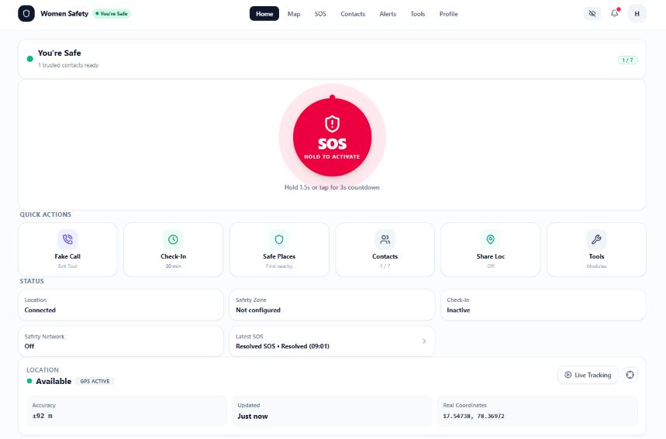
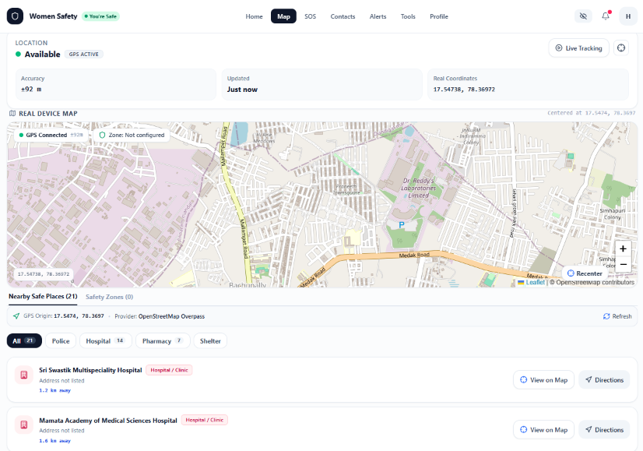
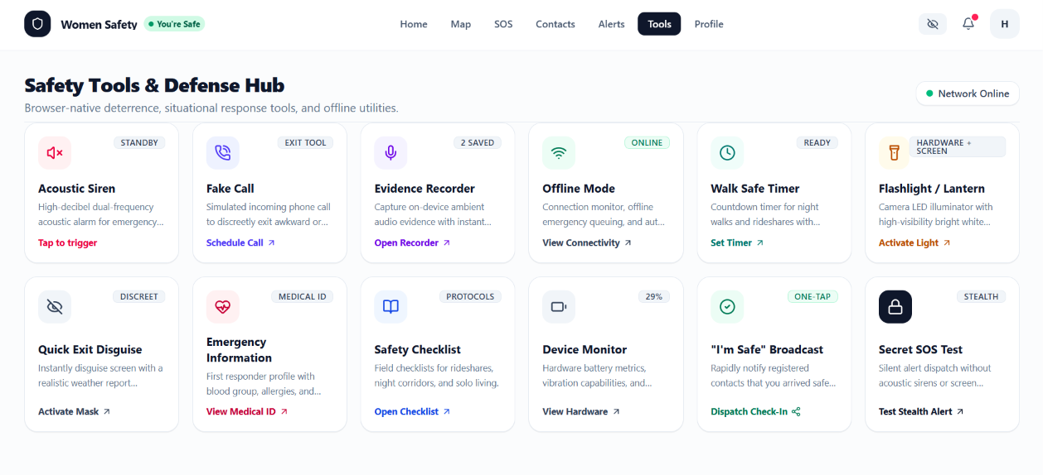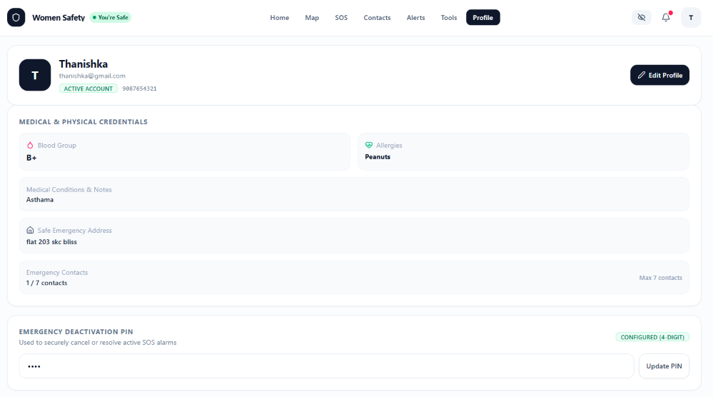

Sample code snippet
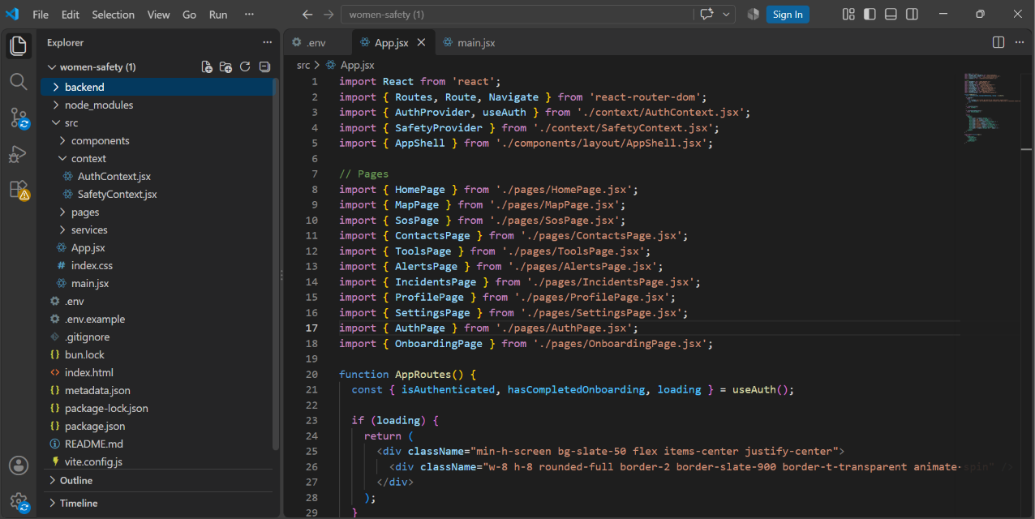
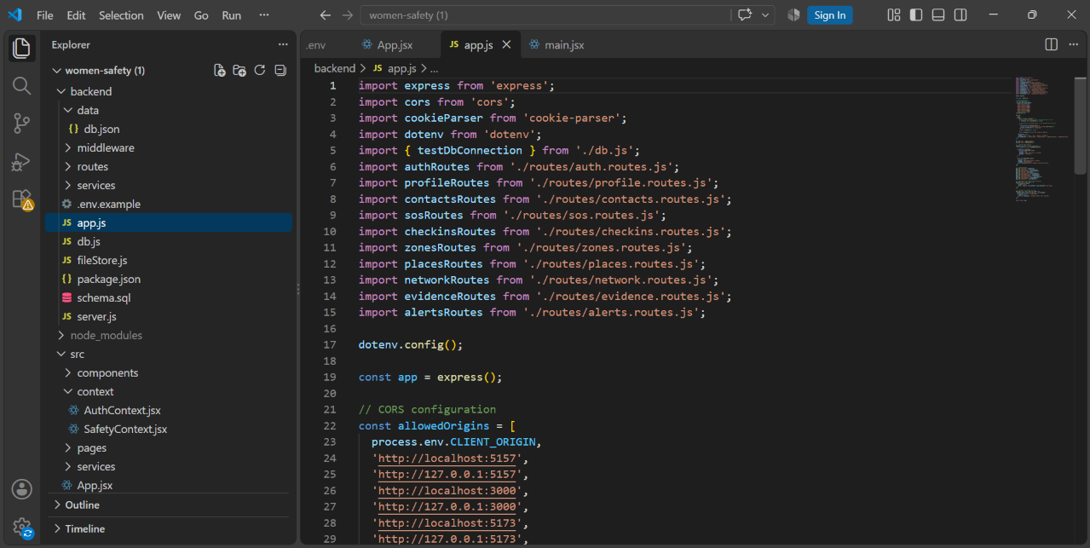

APPENDIX - INSTALLATION AND USER GUIDE

Installation/Setup Instructions
The Women Safety application is a full-stack web application developed using React, Vite, JavaScript, Node.js, Express.js, and MySQL. The project can be set up on a local computer using a suitable development environment such as Visual Studio Code. The application requires the frontend, backend, database, and required environment configuration to be available before running the complete system.
First, download or copy the complete Women Safety project folder to the local computer. If the project is provided as a ZIP file, extract the ZIP file using any standard extraction utility. After extraction, open the project folder in Visual Studio Code. Make sure that all the required project files and folders are present and that the frontend and backend configuration files have not been removed or modified incorrectly.
Next, install Node.js on the computer if it is not already installed. Node.js provides the runtime environment required to execute the backend and install the project dependencies. Open the terminal in Visual Studio Code and navigate to the project directory. Install the required project dependencies using the package configuration provided with the project.
The MySQL database must also be configured before running the complete application. MySQL can be managed using MySQL Workbench. The required database and tables should be created according to the database structure of the project. The backend must be provided with the appropriate database configuration so that it can establish a connection with MySQL.
The application also requires environment configuration for values such as the server port, application environment, authentication secret, and required API keys. These values should be configured through environment variables rather than directly exposing sensitive information inside the source code. The required configuration must be available before starting the backend application.
After completing the configuration, the backend server can be started using the appropriate project command. The frontend can then be started using the Vite development environment. Once both parts of the application are running, the application can be accessed through a modern web browser such as Google Chrome, Microsoft Edge, or Mozilla Firefox.
For production use, the application has been deployed using Railway. The deployed application can be accessed through the production URL:
https://dbse-and-dbd-project-production.up.railway.app/
The local setup is mainly intended for development, testing, debugging, and future modifications, while the Railway deployment provides access to the completed application through the internet.

User Manual or Guide
When the Women Safety application is opened, the user is presented with the application's main interface. New users can begin by creating an account through the registration functionality. During registration, the required user information is entered and submitted through the application. After successful registration, the user can log in using the registered credentials.
After logging in successfully, the user is taken to the application dashboard. The dashboard provides access to the major safety features available in the system. The user can navigate between different sections of the application and access safety functions according to their requirements.
The User Profile section allows the user to view and manage their personal information. Maintaining accurate profile information is important because the application uses the user's account to associate safety-related information with the correct user.
The Emergency Contacts section allows users to add and manage people who can be considered emergency contacts. Users can add the required contact information and manage previously stored contacts. The information is processed through the backend and stored in the database.
The Normal SOS feature provides a direct safety-related action that can be activated by the user when assistance is required. The application processes the action according to the implemented safety workflow.
The Secret SOS feature provides an alternative method of activating a safety-related function. It is designed to provide a less obvious interaction method when the user may not want to use a conventional visible SOS action.
The Location feature provides access to location-related functionality. When required, the application can request permission to access the user's location through the browser or device. The availability and accuracy of the location depend on the device, browser, location services, and permissions provided by the user.
The Safety Timer allows the user to configure a safety timer according to the situation. The user can start the timer and use the application to monitor the configured safety period. This feature can be useful when a user wants to establish a defined period after which they should confirm their safety.
The Safety Check-in feature allows the user to confirm their safety status. This provides a proactive safety mechanism where the user can indicate that they are safe after a particular activity or period.
The Safe Zones feature provides functionality for managing locations that the user considers safe. Users can configure and manage relevant safe locations through the application. Location-related functionality depends on the permissions and services available on the user's device.
The Fake Call feature provides a simulated call interface that can be activated by the user. It is intended as a personal safety-support feature that can help a user create an opportunity to leave an uncomfortable situation.
The application provides navigation between its different sections through the available interface controls. Users can return to the dashboard and access the required functionality whenever necessary. Appropriate messages and interface responses are provided to indicate the status of different operations.
For the best experience, users should provide the required browser permissions, particularly for location-based functionality. A stable internet connection is also recommended because the application communicates with the backend and database to process user operations.
The application is intended as a safety-support system and should not be considered a replacement for official emergency services. The effectiveness of location and emergency-related functionality can depend on network availability, device status, browser permissions, and other external conditions.

Geo Tag photos with guide
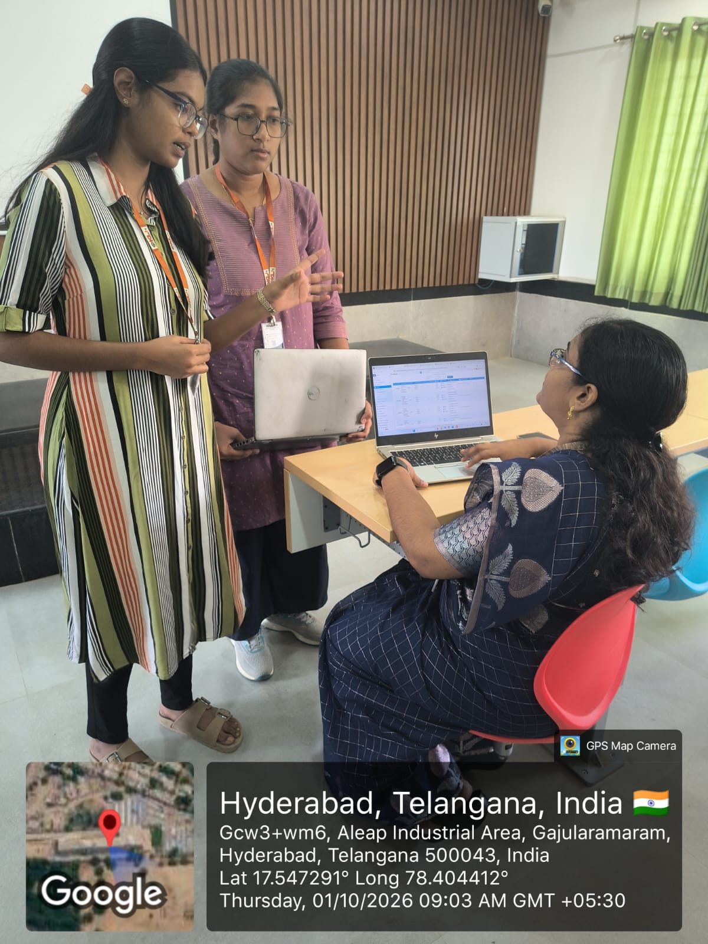

Review forms with guide signatures

